

Being a teacher with disabilities: Perspectives, practices and opportunities
Professor Nidhi Singal Dr Patricia Kwok
Dr Thilanka Wijesinghe

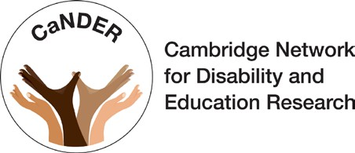
In partnership with

ISBN: 978-1-915280-41-1
DOI: https://doi.org/10.57884/np7v-wc92 Published by the British Council
British Council
1 Redman Place Stratford London
E20 1JQ
© British Council 2024
www.britishcouncil.org

Citation:
Singal, N., Kwok, P., & Wijesinghe, T. (2024). Being a teacher with disabilities: Perspectives, practices and opportunities. British Council. https://doi.org/10.57884/NP7V-WC92
Photo credits: © British Council and © Mat Wright unless otherwise marked.


Acknowledgements

The research team of the Cambridge Network for Disability and Education Research (CaNDER) would like to extend their heartfelt thanks to all the participants, who generously devoted their time towards supporting this research. We are grateful that they shared their personal insights and photographs, which have deeply enriched our understanding of the everyday realities experienced by teachers with disabilities. Our gratitude also extends to the British Council for funding and supporting this research, in an area that does not draw much attention. This includes British Council country offices in Brazil, Jordan, Rwanda, Spain and Sri Lanka, who offered valuable opportunities for us to reach out to teacher groups and relevant educational stakeholders. Last but not least, many thanks to Ebru Weston, Steve Copeland and John Shackleton for their feedback on an initial draft of this report.

About the British Council

We support peace and prosperity by building connections, understanding and trust between people in the UK and countries worldwide.
We work directly with individuals to help them gain the skills, confidence and connections to transform their lives and shape a better world in partnership with the UK. We support them to build networks and explore creative ideas, to learn English, to get a high-quality education and to gain internationally recognised qualifications.
We work with governments and our partners in the education, English language and cultural sectors, in the UK and globally. Working together we make a bigger difference, creating benefit for millions of people all over the world.
We work with people in over 200 countries and territories and are on the ground in more than 100 countries. In 2022–23, we reached more than 80 million people directly and 791 million people overall, including online, through broadcasts and publications.
Founded in 1934, we are a UK charity governed by Royal Charter and a UK public body.

Contents

Foreword 2
Executive summary 3
SECTION 1: Introduction 6
Research questions 7
SECTION 2: Insights from the existing research evidence 8
Positive impact in shaping inclusive classrooms 10
Students’ perceptions of their teachers with disabilities 10
Reasons for becoming a teacher 11
Challenges faced and levers of success 11
Teachers with disabilities: Preparedness, internships and training 12
SECTION 3: Research approach 13
Research process: Sampling 13
Data-collection methods 15
Data analysis 16
SECTION 4: Research findings 17
Country contexts: Official discourses 17
Being a teacher with disabilities 20
Strategies used by teachers with disabilities to function effectively in
the classroom 30
Teachers’ experiences of teacher preparation and professional
progression 36
Recommendations for promoting effective inclusion of teachers with disabilities 40
Country overviews 49
SECTION 5: Next steps 51
Recommendations for national governments 51
Recommendations for educational programme design 52
Recommendations for programme monitoring, evaluation, research
and learning 53
References 54
Appendix 1: Example poster used for recruitment 57
Appendix 2: Policies and official documents examined across the
five countries 58

2 Being a teacher with disabilities: Perspectives, practices and opportunities

Foreword

In our efforts to build education systems that are inclusive and equitable, it is crucial to take into account the experiences and perspectives of teachers with disabilities.
Teachers play a vital role in serving as positive role models and promoting inclusivity within the education sector. Embracing inclusivity enhances the educational experience for students and contributes to a broader societal shift towards understanding, empathy and equal opportunity.
Teaching requires diversity of knowledge, skills and experience as well as qualities such as resilience and adaptability. However, for teachers with disabilities, these qualities can take on heightened significance as they navigate the challenges they encounter in their professional lives.
This research delves into these challenges as well as the strengths and opportunities teachers with disabilities bring to the profession. It aims to foster a deeper understanding of both the barriers that may hinder
day-to-day work and professional development and the strategies used to function effectively in the classroom. It also explores the support mechanisms available to teachers with disabilities at a policy, institutional and personal level. In doing this, the research acts and builds on an exploratory study carried out in 2021 by the British Council, which found that teachers with disabilities remain on the margins of research, resulting in little understanding of the lived experiences of teachers with disabilities in most countries around the world.
We set out to undertake this cross-cultural research with the value of reciprocity at its heart. The findings presented in this report are based on interviews with teachers with disabilities and on policy and literature reviews. They are a call to action for policymakers, leaders of educational institutions and the broader community to not only acknowledge and build on the unique skills and experiences that teachers with disabilities bring to the classroom but also to nurture environments that empower and support them. By amplifying strengths and opportunities and by addressing challenges, we can collectively work towards a more inclusive educational environment that benefits teachers with disabilities and the entire spectrum of learners that these teachers inspire.
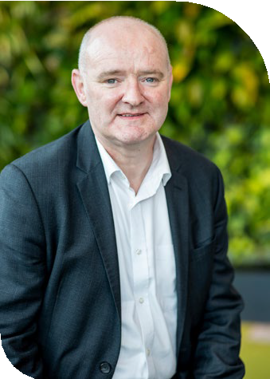
Michael Connolly
Director English Programmes British Council

Executive summary

An inclusive education system is a fundamental pillar for the full participation of persons with disabilities in society. Its significance is affirmed in Sustainable Development Goal 4, which aims to ‘Ensure inclusive and equitable quality education and promote lifelong learning opportunities for all’. However, thinking about inclusive education has remained largely focused on children, and as the Transforming the education workforce report (The Education Commission, 2019) highlights, ‘inequities in the workforce itself are rarely recognised or addressed in the design, training, professional development, or career opportunities for the workforce’. This is clearly the case for teachers with disabilities, as evidenced by their absence in international declarations and most national documents. The first ever Global report on teachers (UNESCO & International Task Force on Teachers for Education 2030) highlights that ‘data relating specifically to facilities and services for teachers with disabilities is extremely scarce globally’.
Our comprehensive review of the literature (covering 1990–2024) focusing on teachers with disabilities in mainstream settings highlights significant gaps in understanding of the issue. We found 87 articles in English language peer-reviewed international journals, nearly half of which were from the United States. Across these studies, a few consistent themes emerged that highlighted the significant positive impact of teachers with disabilities in shaping inclusive classrooms. Teachers with disabilities were seen to ‘embody the discourse of inclusion’ (Singal & Ware, 2021: 30) through their pedagogies. They were seen as more likely to be empathetic, respectful of differences and positive ‘agents of change’ (Glazzard & Dale, 2015: 179). Additionally, themes around challenges faced by teachers with disabilities, such as navigating institutional barriers and social stigma, which results in disability primarily being viewed through a deficit lens, were noted. However, the significant enabling role of line managers as well as the importance of individual agency in seeking accommodations and adaptations are also strongly evident. In recent years, issues of teacher preparedness and training have gained more traction and emphasise the need to support trainee teachers from the very start of their training programme, and to help them develop a sense of purpose and a professional teaching identity (Moore et al., 2020).
Although there is a lack of attention towards teachers with disabilities in policy discourses and research, the fact remains that they are part of the workforce (many people enter the profession with a disability, while others might acquire it once in the profession). As more children with disabilities enter mainstream schools, teachers with disabilities are vital for creating an inclusive culture, among many other things.
Foregrounding the participation of teachers with disabilities also opens new pathways of employment opportunities for persons with disabilities.
This report focuses on addressing the following questions:
- What policies and guidelines exist in the selected five countries to support teachers with disabilities in their work? What are the key challenges and gaps in policy related to supporting teachers with disabilities?
- What are the experiences of teachers with disabilities in mainstream schools and how are these shaped by different contextual variables (e.g. subjects, gender, types of disability)?
- What strategies do teachers with disabilities implement to function effectively in classrooms?
- What are the experiences of teachers with disabilities in relation to teacher preparation and professional progression?
- What recommendations can be made to better support teachers with disabilities and promote greater inclusion and accessibility in their teaching contexts?
Through a qualitative research approach, data was generated using semi-structured interviews and various participatory methods with teachers with disabilities in Brazil, Rwanda, Spain, Jordan and Sri Lanka. This report provides rich insights into the lived experiences of these teachers. Twenty-five teachers (14 male and 11 female) took part in the research, with two from Brazil, five from Jordan, nine from Rwanda, three from Spain and six from Sri Lanka.
Teacher participants self-identified as having different types of disabilities, with the majority having physical disabilities (11), followed by visual disabilities (10) and hearing impairment (3). One participant had
Attention-deficit / hyperactivity disorder (ADHD).

Ten participants had been living with their disabilities since birth or a young age, while others acquired their disabilities at later life stages. A review of education policy documents for the five countries was also undertaken to assess the official discourse around teachers with disabilities.

Key findings
In all the five countries, there is a significant number of policies and legislation on inclusive education, specifically in relation to the inclusion of children with disabilities. However, none of these, apart from the Jordanian 10-year strategy for inclusive education, has a particular emphasis on the need to recruit teachers with disabilities to design and deliver training in inclusive education. Teacher narratives across all the five countries were not monolithic, but some overarching trends were evident:
Being a teacher with disabilities: In all countries we found teachers with disabilities working in mainstream settings, although a range of significant struggles were evident. A striking theme emerging from the narratives of teachers in Sri Lanka and Jordan was that of being a teacher at the periphery – that is, being asked to teach subjects that were not considered to be of high importance, or not being given full teaching responsibilities. Most teachers, across different countries, noted a lack of sensitivity and awareness as well as significant complacency at the level of the school management.
Nevertheless, the majority of the teachers shared rich positive accounts of supportive colleagues within their school settings. Their experiences with students in the classrooms were more mixed, with teachers across different countries sharing experiences of being disrespected by students. However, what also emerged is how teachers felt that talking to and sharing with students the nature of their disabilities and the impact it had on their functioning in the classroom was a powerful strategy. Similarly, almost half of the participants noted that engagement with parents of students in their classroom was generally supportive. Parents tended to be more concerned about their child’s learning rather than the teacher’s disabilities. In a Sri Lankan context, teachers who lived and taught in the same village highlighted strong positive experiences of being accepted and respected. However, concerns about negative stigma around disability in the wider society and how it impacted these teachers in their school settings was a shared theme across all the countries.
In the absence of formal support, what emerged most powerfully as factors that improved the working environment of teachers with disabilities were individual agency, resourcefulness and resilience on the part of the teachers. Most participants expressed a strong commitment to promoting disability inclusion through advocating for themselves, although this did take an emotional toll. However, they were also aware of how their struggles for change could impact the lives of other people with disabilities. Teachers highlighted how they were powerful role models for children with and without disabilities, and also how they also helped change wider societal perceptions about disability. Teachers with disabilities viewed themselves as powerful agents for change.
Functioning effectively in classrooms: More than half the teachers noted having no or limited support in fulfilling their teaching responsibilities. Therefore, to function effectively, many of them valued clear and open communication with their students. A few teachers talked about requesting physical modifications to accommodate their mobility and hearing needs, such as getting classes reallocated to the ground floor, requesting ramps and so on. In a few cases, especially in relation to teachers with visual impairments, they talked about how they prepared teaching and learning materials in advance of the class, such as asking someone to draw a diagram or write on a flip chart. Some teachers talked about the potential of harnessing technology, although it is important to flag that they also highlighted their own lack of training in relation to the use of different devices.
Teachers’ experiences of teacher preparation and progression were largely consistent across country contexts and type of impairment and were shaped by considerable negative instances of receiving very little or no support. Teachers with disabilities were more likely to mention the support they received informally from their personal networks and peers during teacher training, which helped them complete the programme. Similarly, career progression opportunities were lacking due to either the teachers’ own perceived inabilities to perform senior roles or the lack of pathways which were open to them institutionally.
In the teacher narratives, there were no significantly gendered themes, apart from small differences in relation to perceptions of career progression.
Additionally, across different country contexts some small variations emerged. However, our aim is not to generalise teacher experiences within or across these countries; rather, the focus is on fostering mutual learnings.

Recommendations

Recommendations for national governments
  - Develop clear recruitment policies for teachers with disabilities.
  - Invest in inclusive teacher training programmes.
  - Empower school leaders to make flexible decisions to support teachers with disabilities to perform their duties.

Recommendations for educational programme design
  - Recruit teachers with disabilities in all programmes.
  - Mandate disability awareness training to ensure that people who are delivering programmes are sensitive to disability issues and can model good practices.
  - Build the capacity of teachers with disabilities to
use EdTech effectively to help support their teaching.
  - Provide professional mentors to teachers with disabilities who can advocate, as needed, but also draw on their experiences to share effective practices.
  - Draw on the convening power of educational organisations to undertake multiple stakeholder consultations to strengthen the implementation of policies, programmes and legislation for teachers with disabilities, including working with teacher unions.

Recommendations for programme monitoring, evaluation, research and learning
  - Develop multilevel and multistage approaches to change that are sustainable, such as building communities of practice for teachers with disabilities, which can help them become active pioneers of change rather than passive recipients of support.
  - Support more research with a specific focus on disability, including collecting disaggregated data on disability. This can be useful for internal monitoring purposes and can also help develop evidence-informed policies and programmes for the wider education sector.
  - Work with teachers with disabilities on impact evaluation to ensure that educational reform efforts draw on their nuanced perspectives to identify both opportunities and challenges in developing inclusive education systems.

SECTION 1

Introduction

An inclusive education system is regarded as a fundamental pillar for the full participation of persons with disabilities in society. Its significance is reaffirmed in Goal 4 of the Sustainable Development Goals (SDGs), which notes the need to ‘Ensure inclusive and equitable quality education and promote lifelong learning opportunities for all’. The key role of education in shaping values that are supportive of sustainable development and in consolidating sustainable societies has long been affirmed in various declarations and commitments.
Paramount focus around inclusive education in these international (and national) efforts has concentrated on improving access to and quality of schooling for children from marginalised groups, including those with disabilities, who historically tend to be the most neglected group in many societies. Even though lifelong learning opportunities and inclusion for all is commonly mentioned, these efforts rarely extend to adults working in school settings. This is powerfully captured in the work of Singal and Ware (2021), who note that ‘teachers with disabilities are not actively included in discussions on inclusive education’ and yet ‘teachers with disabilities embody the discourse of inclusion’ (p. 30).
Transforming the education workforce: Learning teams for a learning generation, a report published by The Education Commission (2019), recognises that teachers are an education system’s biggest investment and one of its greatest levers for change. It clearly asserts that an inclusive teaching workforce is crucial for supporting the increasingly diverse learners’ needs, especially in mainstream educational settings. It however goes on to point out that
‘inequities in the workforce itself are rarely recognized or addressed in the design, training, professional development, or career opportunities for the workforce. This can lead to a workforce that is not representative of the population it serves in terms of gender, disabilities, ethnic, and linguistic groups’
(p. 40). Thus, globally there is very little information, particularly in relation to certain types of impairment groups and in certain regions of the world, about the professional lives of teachers with disabilities. This lack of evidence is clearly noted in the first ever Global report on teachers (UNESCO & International Task Force on Teachers for Education 2030, 2024). It is noted that ‘Data relating specifically to facilities and services for teachers with disabilities is extremely scarce globally’ (p. 130). It promotes that providing inclusive environments, proper resources and adaptations for teachers with disabilities is imperative for their inclusion and retention and is their right.
In recent years, the British Council has been engaged in gathering meaningful insights into the roles, responsibilities, practices and experiences of teachers with disabilities in different countries across the world. An earlier study, English language teachers with disabilities: An exploratory study across four countries, completed in 2021 (Singal & Ware, 2021), drew on the experiences of teachers with disabilities working in mainstream schools in South Africa, Nepal, Rwanda and India. Building on insights from that work, this report extends the geographical outreach and focus to understand the ways in which teachers with disabilities navigate their working lives.

Research questions
The questions that we address in this report are:
- What policies and guidelines exist in the selected countries to support teachers with disabilities in their work? What are the key challenges and gaps in policy related to supporting teachers with disabilities?
- What are the experiences of teachers with disabilities in mainstream schools and how are these shaped by different contextual variables (e.g. subjects, gender, types of disability)?
- What strategies do teachers with disabilities implement to function effectively in classrooms?
- What are the experiences of teachers with disabilities in relation to teacher preparation and professional progression?
- What recommendations can be made to better support teachers with disabilities and promote greater inclusion and accessibility in their teaching contexts?
Through a qualitative research approach, drawing on interviews and participatory methods, we illuminate the professional experiences of teachers with disabilities across Brazil, Rwanda, Spain, Jordan and Sri Lanka. The aim is not to generalise teacher experience within or across these countries but rather to highlight similarities observed, while paying attention to contextual particularities, with an aim to foster mutual learnings.
The narratives gathered provide insights into the enablers that help these teachers thrive, the adaptations and adjustments they make to their pedagogies, and how these teachers draw on their personal and other resources to address challenges faced.
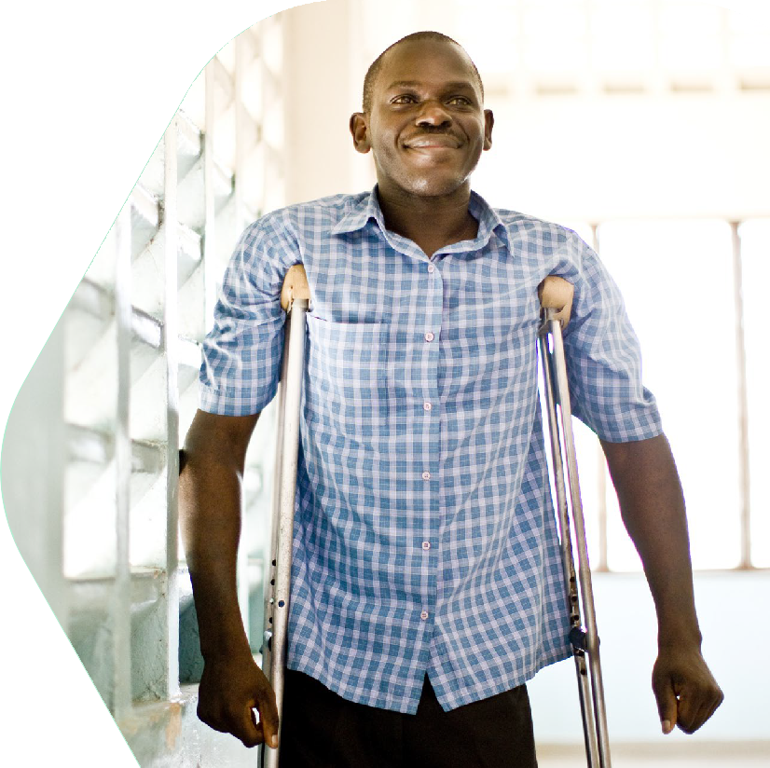
A note on terminology: in this report the term ‘teachers with disabilities’, rather than ‘disabled teachers’, is used, to be in line with the person first language that is more commonly used in many parts of the world and with the language used in the Transforming the education workforce report and the Global report on teachers. This terminology is in line
with the use of the term ‘person with disabilities’, rather than ‘disabled person’, where the aim is to emphasise the person/ individual first and foremost, rather than focusing exclusively on the disabilities.

SECTION 2

Insights from the existing research evidence

This review provides one of the most comprehensive insights into the literature on teachers with disabilities working in mainstream schools internationally. It incorporates and builds on four existing reviews and an updated search of the most recent articles.
Bellacicco et al. (2022), investigating the experiences of teachers with disabilities, identified 32 studies, both quantitative and qualitative, published between 1990 and 2018, and highlighted nine main categories:
1) empathetic understanding, 2) teaching
effectiveness, 3) positive role models, 4) autobiography and professional choices, 5) disclosure, 6) coping strategies, 7) attitudes of school colleagues and students, 8) support from the school/ university, and 9) presence of diversity in the teaching staff. Bellacicco and Demo (2019), using the same time frame in another systematic review, explored aspects of ‘becoming a teacher with a disability’. They focused on inclusion of persons with disabilities in teacher training and identified 22 primary studies.
Singal and Ware (2021) found 59 articles focused on teachers with disabilities working in mainstream settings, while another review, by Neca et al. (2022), found 53 research studies. The ERIC (Education Resources Information Center) database was further checked, and seven research articles relevant to the above topic that were published after 2021 were identified.
In this review, literature from all four above-mentioned reviews and the database search were screened, and a total of 87 articles were identified that had a focus on teachers with disabilities working in mainstream settings, and those receiving teacher preparation programmes. In this collection of 87, most (n=22) focused on the experience of teachers with learning difficulties, primarily those with dyslexia. Teachers with sensory impairments, such as hearing impairments (n=15) and visual impairments (n=12), were the second most frequently engaged with. Eight studies included physical disabilities, a further eight studies discussed a combination of the above-listed disabilities, one related to autism spectrum disorder, and two studies discussed other disabilities such as chronic fatigue syndrome and mental health aspects. Nineteen studies did not specify the types of disabilities of the sample group. Of this collection of 87 studies, the majority adopted a qualitative research design (n=59) and were carried out in the USA (n=43) (see Table 1 for more details).

Table 1: Research into teachers with disabilities: country-specific studies (1990–2024)

Country researched | Frequency of articles
USA | 43
UK | 13
Israel | 5
Canada | 4
Australia | 3
Finland and UK | 3
Italy | 2
Brazil, Ethiopia, Ireland, Malaysia, Nepal, Norway, Portugal, South Africa, Saudi Arabia, Spain, Uganda | 1 each
Comparative studies:  - USA and Canada  - South Africa, Rwanda, Nepal and India  - England, USA and Mexico | 1 each

Only a few studies focused on teachers in a particular subject area. Three studies focused on physical education (USA), two looked at music education (USA), six at English education (UK, USA) and four at science education (UK, Norway, USA), and these were focused across the primary and secondary levels of education. Twenty-nine studies specifically focused on the areas of teacher training and teacher preparation at vocational and tertiary education level. The five key themes that emerge from these studies, which are discussed below, are the following:
- Positive impact in shaping inclusive classrooms
- Students’ perceptions of their teachers with disabilities
- Reasons for becoming a teacher
- Levers of success and challenges faced
- Teachers with disabilities: Preparedness, internships and training.

Positive impact in shaping inclusive classrooms
A recurring finding among different studies is how teachers with disabilities perceived themselves as having an important role in the classroom. Anderson (2006: 368) argues that ‘pedagogy is also shaped by our life experiences. Teachers with disabilities offer knowledge through their bodies and experiences that isn’t usually part of the curriculum. Disabled teachers embody pedagogies of justice, interdependence, and respect for differences.’ Similarly, Hayashi and May (2011) argue that to have a person with a disability as a teacher – a respected expert in their field – contributes more to developing positive mindsets towards disabled people than exposure to disability in other contexts. In relation to teaching and learning, some studies highlight how teachers with disabilities are better able to differentiate learning activities for children, are more empathetic and, particularly, empower students with disabilities (Burns & Bell, 2010, 2011; Griffiths, 2012; Morgan & Burn, 2000).
Various studies working with dyslexic teachers noted their value to classrooms with diverse student populations (Burns & Bell, 2011; Vogel & Sharoni, 2011). Glazzard and Dale (2015: 179) argue that teachers who identified and owned the label of dyslexia could be regarded as ‘agents of change’, actively supporting the process of inclusive education.

Students’ perceptions of their teachers with disabilities
In the early 2000s, rather novel and comprehensive research was undertaken in the US to examine students’ perceptions of the competence of teachers with physical disabilities in teaching physical education (PE) (Bryant & Curtner-Smith 2008, 2009a, 2009b). These studies were conducted across elementary, middle and high schools, in which 100 students were randomly assigned to watch one of two almost identical videos of swimming lessons. In the first video the teacher was able-bodied, and in the second video the teacher used a wheelchair.
Students were then asked to complete a questionnaire on the lesson content and their perceptions of the teacher. Concerningly, the researchers report that as students ‘progress through their schooling, their beliefs about PE teachers with disabilities gradually change for the worse because they are socialised into believing that sport, physical activity, and physical education are for what appear to be whole and fit bodies’ (Bryant & Curtner-Smith, 2009b: 319). They suggest that this is likely due to the limitations of PE curricula, which focus on athleticism and competitive sport. This study is one of the few that address a specific impairment but also gather perspectives across levels of schooling.
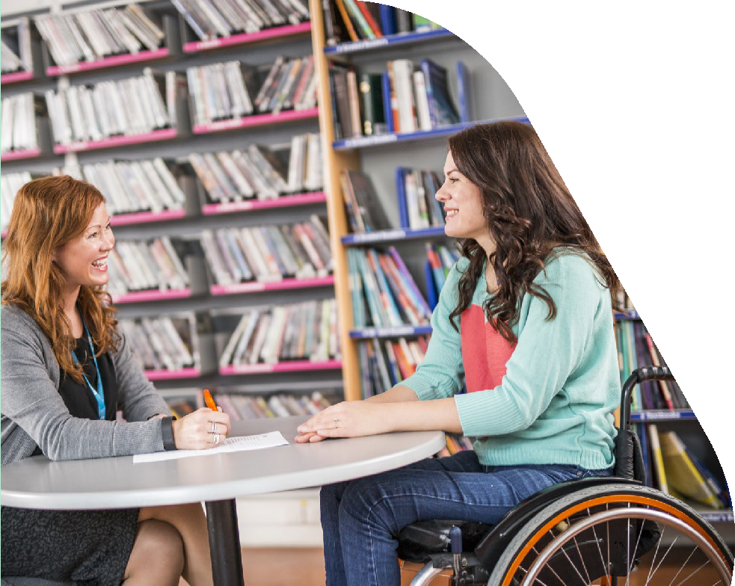
Research by Roberson and Serwatka (2000) focusing on deaf teachers found that secondary students perceived these teachers to be better at teaching and were more positive towards them. In Nepal, Lamichhane (2016), researching teachers with visual impairments working in mainstream schools, reported that students valued these teachers as having good communication skills and positive attitudes, as well as being able to provide strong social and moral lessons.

Reasons for becoming a teacher
Three main themes are identified in the literature as reasons for becoming teachers: pragmatic factors (such as pay, holidays), personal variables (for example passion for working with children, having relevant skills) and a strong sense of social justice (Ware et al., 2022; Ferri et al., 2005). Importantly, some teachers with disabilities argued that they brought additional qualities to the profession in relation to their non-disabled counterparts. Examples included being particularly caring and having empathetic values (Glazzard & Dale, 2015) and being a positive role model as a person with disabilities (Ware et al., 2022). Studies undertaken by Duquette (2000), Morgan and Burn (2000) and Riddick (2003) highlight that while some teachers with disabilities had faced challenges in their own educational experiences as children, this had positively impacted on them as adult practitioners. Additionally, Ferri et al. (2005), undertaking personal history research in the USA, reported strong evidence that when viewed through the lens of the capability approach – focusing on people’s capabilities and functioning – teachers with disabilities describe themselves as competent.
However, it is important to acknowledge the many tensions that some of the teachers faced in relation to disclosing their disability identity. Tensions around whether to disclose identifications of disability, particularly hidden disabilities, are identified in the literature, with Saltes (2020) suggesting that the ‘normalising ideology’ of a ‘capable teacher’ is a substantial barrier that causes both attitudinal and physical barriers. Valle et al. (2004), undertaking
in-depth interviews in the USA with four teachers who identified as having a learning disability, reported significant struggles around disclosure. The stigma around learning disabilities was so strong for some teachers that they felt it was impossible to disclose their disability at work, while other teachers felt that declaring their learning disability offered an opportunity to create positive perceptions of people with learning disabilities (Valle et al., 2004). Glazzard and Dale (2015) found that the threat of ‘standards’ within the education system meant that many trainee teachers choose not to disclose disability.

Challenges faced and levers of success
Ware et al. (2022), working with ten teachers and trainee teachers with a range of disabilities, found that while there was a strong discourse of inclusive education in schools, this did not extend to teachers in schools in England. Nine out of ten teachers faced difficulties and discrimination at work, with the responsibility for accommodations being put on the individual, rather than barriers in the system being addressed. Similarly, Tal-Alon and Shapira-Lishchinsky (2019: n.p.), working in Israel, note that ‘dealing with the school environment is often more difficult and demanding than coping with the disability itself’.
Highlighting levers for success, teachers in Ware et al.’s (2022) study identified the importance of effective line manager support. Some of the teachers spoke of individual attributes that made their line manager effective, such as empathy, personal or familial experience of disability, being a feminist and being a trade unionist. Notably, seeing other successful teachers with disabilities who were more advanced in their careers as role models was also cited as significant. However, due to the lack of teachers with disabilities in England, this is rare. The underrepresentation of teachers with disabilities is an international issue, and ensuring more people with disabilities can access teacher training is vital to ensuring greater representation, diversity and inclusivity in the workforce. Valle et al. (2004: 15) argue schools to be ‘powerful social and political institutions in which discourses of disability circulate’, and these discourses are supported by teacher training programmes that often frame disability through a deficit lens. Actively disrupting these discourses (Valle et al., 2004), as well as ensuring greater representation in the classroom (Parker & Draves, 2018), is vital for ensuring the development of more inclusive schools and education systems.
Looking specifically at peer-reviewed journals published in English, it is clear that there is a significant lacuna in papers addressing similar issues in low- and middle-income countries (LMICs), as only four papers situated in LMICs were identified in the Neca et al. (2022) and Bellacicco et. al. (2022) reviews, and these were based in Nepal, Uganda and Ethiopia.

The study in Ethiopia conducted by Hankebo (2018) focused on exploring adopted modes of communication, teaching experiences and perceptions of deaf teachers in inclusive classrooms. Seven deaf teachers from two primary government schools were interviewed, and the findings noted that ‘though deaf teachers have positive perceptions for their career, they lacked appropriate pedagogical skills. It also appears that deaf teachers are highly inconvenienced by communication barriers and poor interaction, lack of technology usage, and lack of sign language interpreters’ (p. 477). In a mixed-methods study across seven schools from four different districts in Nepal that were employing teachers with a visual impairment, Lamichhane (2016) reported that these teachers tended not to teach subjects such as science and mathematics that require frequent use of a blackboard or illustrations of formulas. They also faced several challenges in lesson preparation, marking students’ examination papers or teaching picture-based content, due to the absence of an adequate support system, educational materials and resources. However, positive attitudes, good communication skills, as well as giving more social and moral lessons, were reported by students as strengths of these teachers.
The qualitative study in Uganda, conducted by Wormnæs and Sellæg (2013), noted how audio- described educational videos may assist inclusive and reflective learning processes among blind teachers and student teachers in an East African context.
Twelve visually impaired and six sighted teachers provided their experiences of audio-described educational video material.

Teachers with disabilities: Preparedness, internships and training
The issue of teacher preparedness emerges as a prominent theme in studies conducted in the USA (Moore et al., 2020; Antilla-Garza, 2015; Pope et al., 2001; Haselden et al., 2007; Brulle, 2006). Through the experiences of teacher candidates with disabilities, Moore et al. (2020) emphasised the need to construct a sense of purpose and a professional teaching identity during the training. Antilla-Garza (2015), exploring the professional certification programmes for future P-12 teachers in Liberal Arts colleges, poses the question, ‘are we doing our part to support our teacher candidates while they are in our programmes?’, highlighting the need to support teacher candidates. This line of exploration is further supported by Saltes (2020) in Canada, who examined the ableist expectations in academia and the accessibility of persons with disabilities to the teaching profession through the views of nine disabled graduate students. Another group of Canadian researchers, Wilson et al. (2018), attempted to redefine being a teacher based on the perspectives of teachers with disabilities.
The importance of teacher training and preparation has been further emphasised by Subrayen and Suknunan (2019), from South Africa, and Haselden et al. (2007), from the USA. They noted that supporting teachers with disabilities right at the start of their training, such as during teaching practicums and teaching internships, was essential. The former study emphasises the need for developing learning communities, while the latter discusses the need to develop a mentoring programme. Based on an extensive survey of disability and initial teacher education (ITE) in the Republic of Ireland, Keane et al. (2018) established the first national dataset about disability in Irish state-funded ITE. The survey found that even though there was an increase in the proportion of students with disabilities entering ITE at the postgraduate level, applicants with disabilities were significantly less likely to be accepted into undergraduate primary ITE.

SECTION 3

Research approach

This research adopted a qualitative approach to get rich insights into the lives of teachers with disabilities. We begin by discussing the research process, including the sample of participants, followed by a discussion on the research methods employed. This section concludes by discussing our analytical approach.

Research process: Sampling
Given that legal definitions of disability differ across country contexts, and there exists wide discrepancy in diagnostic provisions and the lack of a shared cross-cultural language around disability, we used the word ‘disability’ without defining it, the aim being to encourage recruitment of participants who self- identified as being a person with disabilities.
In line with the vision of inclusive education, all teachers in the study were working in mainstream schools, instead of special schools. Even though the original plan was to focus on English language teachers, this criterion was subsequently broadened to include any subject in the mainstream curriculum. This decision was also made in consideration of the scarcity of teacher participants who specialised in English. For example, in Sri Lanka, a key stakeholder noted that there was a significant teacher population with physical and visual disabilities (not hearing impairment) working in mainstream schools, but not many were assigned to teach English. Findings emerging from this research highlight that teachers with disabilities are more often assigned to teaching subjects that are not considered to be centrally important in the official school curriculum.
The final sample includes teachers with disabilities who self-identified as being disabled and were teaching different subjects in mainstream schools, across primary and secondary settings.
An ethical review of the project and clearance was approved by the Faculty of Education, University of Cambridge (Ethics_003_2324). Given the geographical spread of this project, participants were sought through various means. Advertising materials – namely country-specific with details about the aims of the project, research activities and ways to express interest – were shared with the British Council’s country offices in each of the five selected countries (see Appendix 1 for the type of poster used).
Information was also shared through professional networks, for instance the Cambridge Network for Disability and Education Research, and prior in- country connections such as local universities.
Interested teachers were invited to complete an online form to share basic information, including gender, level(s) and subject(s) taught, years of teaching experience, type of impairment and contact details.
In total, we received 47 initial responses of interest, some of whom did not reply or did not meet the criteria. Finally, 25 teachers (14 male and 11 female) successfully took part in the research, with two from Brazil, five from Jordan, nine from Rwanda, three from Spain and six from Sri Lanka. Teacher participants self-identified with having different types of disabilities, with the majority having physical disabilities (11), followed by visual impairment (10) and hearing impairment (3). One participant had ADHD. Ten participants had been living with their disabilities since they were born, while others acquired their disabilities at various stages of life.
More details are provided in Table 2. To maintain anonymity across our participants, we use pseudonyms in all cases, except one where the teacher gave explicit permission to use her photograph and name.

Table 2: Overview of participants

Teacher’s name | Country | M/F | Subject(s) taught | Disability/Impact on functioning
Gilberto | Brazil | Male | English; Portuguese | ADHD that is managed with medication
Analu | Brazil | Female | English | Hearing loss in both ears, which requires hearing aid in both ears
Haniya | Jordan | Female | English | Hearing loss, which requires hearing aid in both ears
Chadia | Jordan | Female | English | Low vision, requires the use of a Braille laptop
Latifa | Jordan | Female | English | Blindness, relies on Braille systems
Amina | Jordan | Female | English | Blindness, relies on technology such as smartboards for written communication
Fadel | Jordan | Male | Social studies | Blindness, relies on Braille systems
Mugisha | Rwanda | Male | English | Reduced mobility due to only one arm
Nshuti | Rwanda | Male | English; Maths; French; Kinyarwanda | Reduced mobility as only one healthy leg
Shyaka | Rwanda | Male | Social studies | Reduced mobility as only one healthy leg
Keza | Rwanda | Female | English | Reduced mobility due to only one healthy leg
Uwamahoro | Rwanda | Female | English | Reduced mobility due to only one healthy leg
Ganza | Rwanda | Male | English;  General studies; Communication skills | Reduced mobility due to only one healthy leg
Mutoni | Rwanda | Female | English | Reduced mobility due to only one healthy leg
Ngoga | Rwanda | Male | English; Kinyarwanda | Reduced mobility with only three fingers on each hand
Nkurunziza | Rwanda | Male | Range of subjects | Mobility restricted in the hands due to an accident
Mar | Spain | Female | English | Physical disabilities resulting from Dwarfism/ Achondroplasia. Requires assistance from physical adaptations such as steps, sticks
Pablo | Spain | Male | English | Hearing loss, requires the use of hearing aids in both ears; also reported as having ADHD and dyslexia
Lucia | Spain | Female | English | Reduced mobility due to paresis in one leg
Asiri | Sri Lanka | Male | Citizenship education; Music | Blindness, relies on Braille system and white cane
Chathura | Sri Lanka | Male | Communication & media studies | Low vision assisted with glasses
Dayani | Sri Lanka | Female | Buddhism | Blindness, relies on Braille system
Sanhitha | Sri Lanka | Male | ICT; Buddhism | Low vision, relies on glasses and magnifying lenses
Buddika | Sri Lanka | Male | Music | Blindness, relies on Braille system
Chaminda | Sri Lanka | Male | Music | Blindness, relies on Braille system and white cane

As is evident from the overall sample, there was significant difference in the uptake of the research across different countries (for example, high numbers in Rwanda but very few in Brazil), but also interesting notable patterns existed within countries (for example, in Sri Lanka all teachers had a visual impairment). It is important to emphasise that this is a self-selected sample; given the lack of data on teachers with disabilities in mainstream settings in these countries, it is not possible to know how these trends map out at the national level.

Data-collection methods
From the outset of the project, it was clear that the methods of data collection should centrally focus on listening to the voices of teachers with disabilities; hence, a decision was made to generate a few different options and then let individuals decide what suited them the best.
At the beginning of each conversation, the following information was shared with participants:
- information about the research team members and the funder
- the purpose of the research
- the procedures of the research and the expectation of these tasks, such as the type of questions and duration
- how the data will be used and stored, such as the issues of anonymity and confidentiality
- the research output and potential impact on future efforts related to disability inclusion.
Participants were also given the opportunity to ask questions, after which verbal consent was obtained from each participant to confirm their willingness to participate voluntarily. In all cases, airtime or equivalence was offered to participants to compensate for the cost incurred from using mobile credits or data, since all research-related communications took place online.

Individual semi-structured interviews
We gathered primary data from teachers with disabilities using semi-structured interviews and a range of participatory methods. The interviews were focused on the following themes:
- the type(s) of disability and impact on teaching
- motivation for becoming a teacher
- identity as a teacher with disabilities
- experiences with teacher training, teaching in current schools, career progression
- strategies to navigate any challenges encountered
- experiences and engagement with the school communities: students, school leaders, parents and fellow teachers
- reflections on any enablers and future recommendations to improve disability inclusion.
After completing the semi-structured interview, all teachers were invited to take part in a participatory activity, which included a choice between audio-notes and a photo-elicitation activity. Adaptations were made to these methods to accommodate individual needs and circumstances.

Photo-elicitation
Photo-elicitation is a technique often used in participatory research when the social phenomena are difficult to be articulated by words alone. It also empowers participants’ agency to capture their experiences in real time and first hand to allow for a more equitable relationship between the researcher and participants (Catalani & Minkler, 2010). We invited teachers to share with us not more than five photos and/or audio-notes addressing each of the following questions:
  - What are the things that help support your role as a teacher with disabilities in the classroom or school?
  - What are the challenges in your work?
  - What can help you be a more effective teacher with disabilities at school?
All teachers were reminded of basic ethical protocols such as not taking pictures of people’s faces, rather to use objects and other alternative representations.
Considering individual needs and preferences, several modifications were made to this data- collection approach. For example, the participants with hearing impairment preferred both mediums (auditory and visual). Hence, instructions for the photo-elicitations were provided in written and spoken format. For teachers with visual impairment and some teachers who did not have a device for taking photos, audio-notes were received that described what they felt.
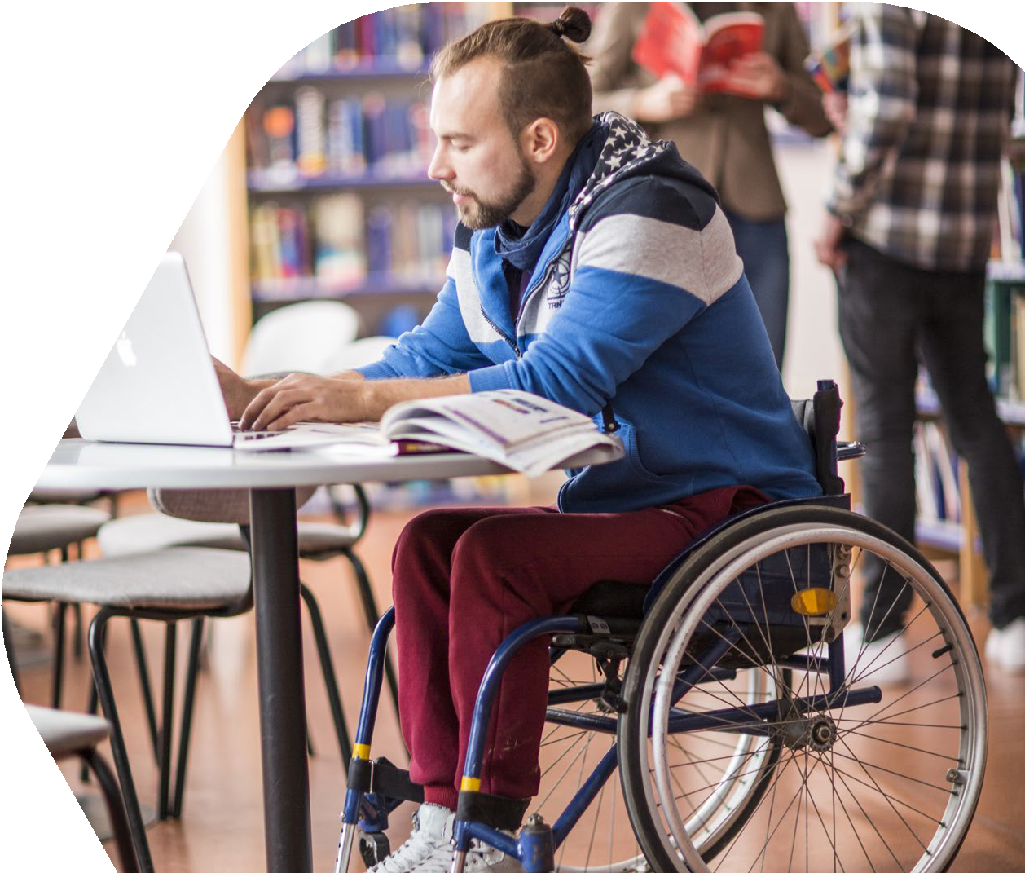
Working across international contexts, we were also very mindful of the known technical challenges, such as participants not necessarily having the capacity to connect online and hardware issues, especially in contexts with limited power supply and resources.
When interrelated challenges were experienced from using a language that is not the teachers’ home language with unstable internet in an audio-call, one mitigating strategy was to send teachers questions that were unclear or difficult to understand on WhatsApp. This enabled the clarification of queries with more swiftness and allowed teachers to process the responses in their own time. Nonetheless, language emerged as a key challenge, especially in Rwanda and Sri Lanka. This clearly impacted the quality of interviews in Rwanda. However, in Sri Lanka, given that we had a team member fluent in Sinhala, we were able to conduct interviews in the local language and then transcribe them into English, resulting in very rich narratives.

Analysis of official documents
A review of current government policies in each of these countries was undertaken to identify any information on teachers with disabilities that specifically focuses on their recruitment, retention and progression. This review was notably restricted in scope, given the reliance on official documents that were available online and in the English language.
Nonetheless, in Rwanda and Sri Lanka we were able to corroborate the lack of such official documents with follow-up conversations with two senior government officials.

Data analysis
All the semi-structured interviews and photo- elicitation interviews were transcribed. Subsequently, an NVivo-assisted thematic coding analysis, following Braun and Clarke’s (2012) approach of reflexive thematic analysis, was undertaken. All transcripts were distributed among the researchers and coded independently, following a similar code sheet. Initial themes were then generated, based on the coded data, knowledge of literature and the focus of the research. During the analysis, the focus was on identifying common themes across the dataset, while also paying attention to patterns emerging from specific teachers’ attributes, such as gender, types of disabilities and country context.
In the photo-elicitation task, despite reminders, some of the teachers had captured the faces of their students and colleagues. To ensure a stringent ethical protocol, we have not included such pictures except in one case where the teacher gave us explicit permission to use her photograph.

SECTION 4

Research findings

This section brings together key findings emerging from analysis of official documents, teachers and the photo-elicitation methods. We present the findings from our analysis in different ways. We begin by providing a snapshot of findings emerging from analysis of official documents, before moving on to presenting teacher narratives. This section begins by highlighting overarching themes across the data and the impact of type of disability and gender, where feasible. To illuminate different stories and provide more depth, various case studies have been presented. The section ends with an overarching snapshot for each of the five countries.

Country contexts: Official discourses
The Education Commission report (2019), titled Transforming the education workforce: Learning teams for a learning generation, is one of the very few current international reports that bring into focus teachers with disabilities, at least in passing. It points out that inequities in the teaching workforce are not representative of the population it serves in terms of gender, disabilities, ethnic and linguistic groups. The lack of any supportive pathways through teacher training, career progression and retention can result in their continued exclusion and continued underrepresentation in the workforce. It also reinforces a negative feedback loop and can have a detrimental impact on students and the wider agenda of inclusive education.
Therefore, it is imperative that new approaches are adopted to ensure routes into teaching are accessible for underrepresented groups, especially people with disabilities, who have traditionally been excluded from mainstream education systems. To address some of these issues, the report suggests the need for ensuring that training courses are inclusive in terms of trainee accessibility, course content, assessment
and trainers. The UNESCO Global Education Monitoring (2020) report, Inclusion and education: All means all, similarly mentions teachers with disabilities in passing and does not really delve into any details. For example, it uses an Office of the High Commissioner for Human Rights reference to note that the government of Bangladesh, with donor support, recruited 650 primary school teachers with disabilities, about 70 per cent of them women, but the reference is not stated in the bibliography, making it impossible to follow up on the details of this programme.
While there is not a significant focus on teachers with disabilities (in contrast to a focus on teacher and gender) in international reports, there are a few countries where a stronger advocacy focus seems to operate. For example, the NASUWT, a teacher union run throughout the UK, holds conferences/webinars for disabled teachers on a regular basis.
All five countries included in this study have a significant number of policies and legislation on inclusive education, specifically in relation to the inclusion of children with disabilities in education. The aim in this section is not to repeat this information, as there are several review papers on this topic (Lacruz- Pérez et al., 2021; Nilholm, 2021; Humanity & Inclusion, 2021; UNICEF, 2021; Cenci et al., 2020).
Rather, the focus is to specifically understand whether and how the official discourse around inclusive education incorporates teachers with disabilities. An online search of documents available in the English language resulted in the identification of a total of eight official documents for Rwanda, eight for Jordan, two for Brazil, two for Spain and seven for Sri Lanka (Appendix 2). When examining these documents, the focus was very specifically on identifying references to teachers with disabilities. Across all these documents, we did not find any mention of teachers with disabilities, except for one, in the case of Jordan.

Brazil
The Brazilian legislation on the Inclusion of Persons with Disabilities (Statute of Persons with Disabilities) – explicitly, Law No. 13.146/2015 also known as the Brazilian Inclusion Law (LBI) – addresses the rights of persons with disabilities through a biopsychosocial lens. Included in Article 37 of this law (No. 13.146/ 2015) are a series of affirmative measures, which include a reservation quota of two to five per cent of
jobs for people with disabilities in companies with 100 or more employees. However, the level of compliance with the above-mentioned quota was reported to barely exceed 50 per cent (EUROsociAL, 2021). The available statistics for Brazil (2010) indicate the employment-to-population ratio for persons with and without disabilities as 48 per cent and 64 per cent, meaning that people with disabilities are generally less likely to be employed than people without disabilities. Furthermore, women with disabilities are employed at lower rates (25 per cent) than women without disabilities (49 per cent) or men with disabilities (39 per cent) (ILO & OECD, 2018). Inferring the status of teachers with disabilities specifically in these reports was not feasible. In documents written in English, we were unable to find any specific mention of teachers with disabilities.

Jordan
The Constitution of Jordan through Article 6 (ii) states, ‘the government shall ensure work and education within the limits of its possibilities, and it shall ensure a state of tranquility and equal opportunities to all Jordanians’ (The Hashemite Kingdom of Jordan, 1952). Law No. 20 in 2017, the Rights of Persons with Disabilities Act, Article 17, notes that ‘it is forbidden to exclude someone from any educational institution based on, or because of, disability’. The 10-year strategy for inclusive education, by the Higher Council for the Rights of Persons with Disabilities & Ministry of Education in 2020, also addresses how the Ministry would enforce social justice and maintain the right to education for all segments of society.
Interestingly, Jordan is the only country where we found an explicit mention of teachers with disabilities. The Higher Council for the Rights of Persons with Disabilities & Ministry of Education (2017) in the
10-year strategy for inclusive education, under the section on Human Resources and Capacity Building, explicitly identified promoting positive behavioural attitude through ‘recruiting teachers with disabilities to design and deliver training in inclusive education’.
Furthermore, teachers’ involvement was strongly emphasised in supporting students with disabilities, highlighting the need for the preparation and training of teachers, for example providing logistical support such as courses in sign language, Braille and disability etiquette or the etiquette of communicating with students with disabilities. While acknowledging the common misperception, challenges and risks to implementation of inclusive education, the need for relevant knowledge, attitudes and skills for providing inclusive services for children with disabilities in Jordan was highlighted by stating significant obstacles such as the limited availability of specialised diagnostic centres for persons with disabilities, the lack of qualified male and female specialists, the absence of appropriate diagnostic tools and the lack of specialised curricula and appropriate learning environments.

Rwanda
In Rwanda, the National policy of persons with disabilities and four-year strategic plan (2021–2024) (Ministry of Local Government – MINALOC, 2021) notes that persons with disabilities should be supported in all sectors, with a cross-cutting goal to strengthen disability coordination and inclusion across all sectors, and further informs that ‘persons with disabilities have access to employment opportunities that accommodate their specific needs’ (p. 31). The 2021 Labour force survey (National Institute of Statistics of Rwanda – NISR, 2021) provides data on labour force participation for persons with disabilities, but there is no data available for their participation in the education workforce.
The 2007 Teacher development policy features training and sets out to reorganise the funding for teacher training to strengthen the support given to primary and secondary training, as well as providing funding for in-service teacher development.
Nevertheless, in looking at representation in higher education, few students with disabilities access university-level education. For example, the 2018 Special needs and inclusive education strategic plan reports that only 0.48 per cent of all students enrolled in tertiary education are those with disabilities, with the 2021 Rwandan statistic yearbook (NISR, 2021) reporting that for the academic year 2017/2018, only 110 students with disabilities (0.15 per cent) being enrolled in tertiary education. The Revised special needs and inclusive education policy (Ministry of Education – MINEDUC, 2018) highlights

the importance of accessibility for both students and educators, underlining a commitment to ‘developing conditions that are adequately conducive for all learners and educators to interact in a barrier-free and child-friendly educational environment’ (p. 1).

Spain
The Royal Legislative Decree 1/2013, also described as the General Law on Rights of Persons with Disabilities and their Social Inclusion, since 2013, is the main law protecting a person with a disability in Spain. It is a consolidation of three key laws (General Law 13/1982 on rights of persons with disabilities and their social integration, Law 51/2003 on Equal Opportunities, and Law 49/2007 Equal Opportunities Act). Under this legislation, both private companies and public offices are required to meet a two per cent disability employment target, irrespective of the volume of their workforce. ‘Alternative options’ are provided to the employers if they cannot meet the two per cent target. However, in these, a specific mention of teachers with disabilities is not evident.
According to the Instituto Nacional de Estadística (INE; 2022), the employment rate of people with disabilities was 27.8 per cent when it was 68.1 per cent for persons without disabilities. It is identified that 57.7 per cent of men with disabilities and 42.3 per cent of women with disabilities are currently employed in Spain (INE, 2022). Of those employed with disabilities, 80.6 per cent were reported to be working in the services sector, compared to 75.9 per cent of those without disabilities (INE, 2022).
However, sub-classification within the service sector is not mentioned. In comparison with other countries, in Spain 30.6 per cent of persons with disabilities are in tertiary education (INE, 2022).

Sri Lanka
Sri Lanka ratified the UN Convention on the Rights of Persons with Disabilities in 2016. However, there is no domestic legislation that fully operationalises the international obligations preserved in the Convention. The Rights of Persons with Disabilities Act (No. 28 of 1996) plays a significant legislative role, asserting ‘No person with a disability shall be discriminated against on the ground of such disability in recruitment for any employment or office or admission to any educational institution’. It attempts to ensure three basic rights for a person with disabilities: admission to educational institutions, equality in recruitment for employment, and physical accessibility to public places. A more comprehensive Disability Rights Bill was redrafted in 2016 but has not been officially passed.
In relation to employment of persons with disabilities, one of the significant official circulars, the Public Administration Circular 27/1988, states that three per cent of vacancies in the public sector should be filled by disabled persons. However, evidence of this legislation in practice is obscure, and no official statistics on the participation of people with disabilities in the education workforce are available. According to the census and statistics report 2012,
70.9 per cent of people with disabilities of employment age do not engage in any economic activity.
Given the significant lack of teachers with disabilities in official documents we reviewed, it makes it rather pertinent to delve into more detail about how teachers with disabilities, who clearly were already working in mainstream settings across these countries, experienced life as a teacher. Data emerging from these interviews and reflection activities is discussed below.

Being a teacher with disabilities
A significant focus of our discussions was on understanding how teachers perceived themselves in their professional roles, the kinds of responsibilities they were given or sought, and their relationship with other key stakeholders in their school settings. A range of narratives emerged, which differed across contexts.

The ‘peripheral teacher’
A striking theme emerging from both the Sri Lankan and Jordanian teacher narratives was being a teacher at the periphery. The teachers in Sri Lanka conveyed this by describing their teaching contracts and in relation to the subjects they were given to teach.

Participants commonly described their status as ‘relief’ or ‘support’ teachers. Even after working at the same school for an extensive period, some were not assigned timetables, that is, official teaching responsibilities were not formally allocated. For example, Chaminda (Sri Lanka) described it as ‘I don’t have a timetable at present in my school. Now I have been in this school for seven years, seven service years.’ In Buddika’s (Sri Lanka) experience, despite having demonstrated both competencies in his subject of music and availability, the school leader still preferred to recruit another teacher. The post was later offered to him only when the school ‘had no choice but me … when they couldn’t find a replacement, they gave me [the teaching post]’.
These experiences were often discussed in relation to various attitudinal barriers and discrimination teachers faced at school, especially from school leaders.

When explaining the discrepancies in the allocation of subjects, providing the contextual background, Buddika stated that certain subjects are not really valued:

Maths – Science – English – IT is what is there in Sri Lanka … Always, it must be to write the exam and obtain an ‘A’. The final aim is to become an engineer or a doctor in Sri Lanka
... That is the parents’ situation. Because you can earn a lot from it. That is what is there in Sri Lanka. Becoming a musician is not there. There is no value in it. With all this we tread.

It is worth noting that half (three of the six) of the Sri Lankan teacher participants with visual impairment in our sample were teaching music, which during the interviews was commonly noted as a peripheral subject. This is exemplified in Chaminda’s story, captured in Box 1.

CASE STUDY BOX 1

Chaminda – Sri Lanka
Chaminda is linked to a mainstream school in his own village in Sri Lanka, where he has been teaching music to secondary students for the last seven years. He is ‘totally’ blind now, but had some level of vision till two decades ago. He is not sure about being labelled as ‘disabled’. ‘I don’t like saying “I’m like this” and “I’m like that”. But the others should know about my situation. For my own safety, I often say it because we can’t really change it’.

He did not receive any special considerations during teacher training. There was no specific disability-related teacher training, nor any adaptations made to support his needs. This was ironical given that he was just left to do what he wanted: ‘… now just imagine me, I am given a teaching appointment and let loose in a mainstream classroom, a blind person like myself. Makes you think … like this is “bonkers”. I can’t even imagine …’ He expresses the need for ‘being trained specially, by introducing different teaching methods that teachers with disabilities could use. Such a training will be very useful. If not given, then it is not practical.’ In the absence of any such training, he relies on his own methods and ways of doing things in the classroom.
However, this has also been challenging, especially as he is not able to do things as expected in the system:

I use Braille. So, if I’m asked to do a lesson plan, I will do it through Braille. Because if that lesson plan I made, I can’t read, then it is of no use to me. I will do it in a way that I can read it. We don’t have to make lesson plans only for someone else to read. If they ask me to, I will do so with my system and show them. I would say this is my lesson plan. If you have someone to help you read it, go ahead and read it. That is the best thing to do.

In school he works with another teacher, who teaches the theory part of music. He does not have his own timetable and classes, which does not make him feel part of the school. He expresses his frustration when he observes ‘I took on this appointment to teach. Not to just sit and wait.’ He continues to face many challenges in getting a proper timetable (that is, a class to teach on a regular basis):

Me not having a timetable can’t be my fault. It is the principal who should be giving the timetable at the start of the year. I have been here for the past seven years and people know that I have knowledge of my subject. To provide a timetable is their job. I can’t go requesting and upsetting other people and also then parents coming to me ask why I forcefully took that?

He is very clear that a lot more needs to be done at government level:

… the support should be given at the ministry. Then from the provincial and district offices. The teacher advisors, subject supervisors are there. They should support, not to just drop a blind person in the classroom and expect them to teach.

He also focuses on the need for more systems- level change:

… we have lot of organisations (DPO)… all they ask is, give us jobs. However, after getting the job, they don’t have an aim about what to do in that job. We are placed in a class, but with no support or training.

However, being in a village school where he lives and knows people is empowering and positive. ‘They are used to seeing us. From them there is no indifference or dissatisfaction’. He also drew satisfaction from, and took pride in, the learning that his students achieve.

Similar views were expressed by two teachers in Jordan. Chadia expressed frustration as she recalled how the first headmistress she had worked with called on her services only as an alternative teacher if any teacher was absent. She described this experience as ‘very difficult’ and it made her feel ‘useless’, because this reduced her full responsibility to merely ‘controlling the students’. Amina’s reflection on the teacher recruitment system in Jordan noted that teachers with visual impairment were considered as ‘extra teachers’, who were ‘not required to do anything’. This was attributed to the stereotypical assumption, especially in language subjects like English and Arabic, that teachers with disabilities were unable to write on the board or assess students’ work, and thus ‘they cannot teach students’ (Amina, Jordan).

Complacency at the level of school management
Out of 25 participants, 19 noted that they had not received any support, despite 16 participants openly identifying themselves as teachers with disabilities. A lack of awareness and hence inaction to support teachers with disabilities was a reason often cited by the participants. Ganza (Rwanda) recalled that ‘I was just considered like other people’, which was similarly echoed by Chathura (Sri Lanka) as he described how everything was ‘carried out in the usual way’. Pablo (Spain) observed that ‘it didn’t really have any impact’. Highlighting a significant degree of complacency at the school management level, Latifa (Jordan) noted, ‘When I came to my school, the school manager didn’t know how to deal with me, how to deal with disabilities, how to deal with what kind of work I can do’.
Likewise, Amina (Jordan) recalled that the school leader was ‘confused’ and thinking ‘What should I do?’ She recalled being asked by the head teacher ‘Can you teach? Can you write?’ In Sri Lanka, Sanhitha’s case study (Box 2) highlights similar struggles.
Buddika (Sri Lanka) described that ‘however much we try our best to work with our condition [disability], the management doesn’t seem to have much trust’. This, as the teacher explained, could be attributed to the competitive education system in Sri Lanka, in which school leaders were competing with other schools to ‘win in that competition’ and hence ‘they would always choose what they think is good’, leading to ‘a tendency for us to get rejected’. Chadia alluded to a similar scenario existing in Jordan.
Furthermore, teachers also shared that adjustment often required an official diagnosis of their disability, which was not available at the time. Lucia (Spain) was put on a waiting list to pass the medical examination, and without the result, she described that ‘you are like a normal teacher’ and hence if any support was offered by the school leaders, it was because ‘they want to’ but ‘they don’t have to’. Gilberto in Brazil, who had ADHD, noted that it was not considered a disability, and hence he was not provided any accommodations and/or support.
There was a temporal dimension in some of these narratives, where over time some participants described how they noted a shift in the management’s response. However, this was achieved largely through a significant amount of individual
self-advocacy.

Largely supportive colleagues
Most participants (21 out of 25) shared a rich, positive account of support from colleagues within the school, especially when they asked for help. Six teachers provided examples of how others supported their teaching-related responsibilities. Nkurunziza (Rwanda) noted specifically that when there was a lot of writing needed, other teachers tended to help.
Six teachers, all with visual impairment, described colleagues often as concerned, helpful and welcoming when they needed to move within the school compound and beyond. For instance, in Chadia’s (Jordan) words, ‘even without asking them [other teachers], if they see me outside … “Do you want any help? Can I help you?” ’ Similarly, in Sri Lanka, Dayani’s case study (Box 6) highlights the support she received from her colleagues. Additionally, some noted how colleagues supported them with administrative tasks such as completing documents (Chathura) and writing (monthly) payslips (Dayani and Sanhitha).
Five teachers provided examples of being supported socially. For instance, Nshuti (Rwanda) mentioned that colleagues would visit him when he was unwell.
Ngoga (Rwanda) shared instances when he needed urgent financial assistance and colleagues did not hesitate to lend him money, stating ‘they really help me because of my physically challenge’. In Spain, Pablo likewise appreciated the ‘friendly’ colleagues in his English department, with whom he noted ‘we will chat a little bit about this and that’. Teachers underscored the fact that their colleagues also provided important motivational support. For

example, Asiri (Sri Lanka) noted that colleagues often appreciated him as they said ‘See how far this teacher has come even without seeing from his eyes. Then how much more potential you have to go further’.
This was also echoed by Amina (Jordan).
In contrast, teachers also spoke about the active role they played in supporting other colleagues. In Jordan, Amina provided support to other English teachers: ‘when they have any questions, especially English teachers, they always ask me and we discuss things together in terms of teaching or other issues’. In Sri Lanka, Sanhitha described how he worked ‘co- operatively’ with others and supported them with the ‘technology aspect’ such as printing. Chathura (Sri Lanka) shared how he supported other teachers with personal and professional responsibilities: ‘I tell them a lot of things like changing their phone settings … I connect them with resourceful people and get things done’. Such help, he noted, was well appreciated by his colleagues: ‘What a nice person you are, a very friendly personable and a person who can do more things than the ones who see’.
That said, some (eight) teachers also recalled challenges they experienced while working with their colleagues. These were around the lack of awareness and recognition of teachers with disabilities. This was succinctly summarised in Latifa’s (Jordan) account: ‘It was strange to them to meet like a blind person. So, they didn’t know how to deal with me. Like some of them, need more efforts to convince them I can do something.’
Similarly in Rwanda, Uwamahoro discussed others’ refusal to help because ‘they have no information about disability’. In Sri Lanka, two teachers experienced a notable difference in the way they were treated by older and younger fellow teachers. The latter were said to be more accommodating. In Sanhitha’s words, the tendency was that older teachers thought ‘conventionally’, which referred to the expectation that work would not be adapted, and everything would be carried out in the same way for all teachers with or without disabilities. Speaking about the openness to collaboration with teachers with disabilities, Sanhitha recalled being excluded by older teachers, who were said to have kept him ‘at a side’ and ‘limit me just to the library’. Chaminda, likewise, felt the existence of a ‘generation gap’. In his experience, older teachers ‘don’t like’ to collaborate, whereas younger ones were more open to ‘working together’.

Engagement with students
In terms of experiences with students, around one-third of the participants shared challenges experienced in teaching. Five teachers provided
examples of how students were disrespectful because of the teacher’s disability. For instance, Amina (Jordan) described how students often had misconceptions about disability. Fadel (Jordan) stated how he felt ‘depressed’ after hearing students saying, ‘ “This man is blind. He can’t see” … They are laughing
… they shout and they criticise me, but I can’t say anything’. In Rwanda, Ngoga shared that he was ‘called names’, while Ganza (Rwanda) also shared the uncomfortable feeling that ‘they just look at you as if you are different’. This was also noted by Mar in Spain and is elaborated upon in her evolving experiences with the students in her case study (Box 3).
Apart from the obvious disrespect, two teachers discussed the negative feedback they often received from students. Haniya (Jordan) shared that her students had filed a complaint about their interactional style, as ‘I could not speak to them or answer them’ without the support of hearing aids, owing to her hearing condition. Gilberto (Brazil) often preferred to engage students in peer learning, to accommodate his ADHD, yet he received ‘mean’ or ‘very negative’ comments from students.
Five participants, including four Sri Lankan teachers, shared challenges in terms of classroom management. For instance, Buddika (Sri Lanka) noted ‘if we didn’t have the visual impairment, we could do much better than this’. However, they also reflected that the poor student discipline was not necessarily targeted at their disability. Rather, it was a case of children being ‘… mischievous. That is not being disrespectful to me. That is their “childhood” personalities. That they would do to anyone. With my condition, they may take the opportunity to not do work, or escape from class, all those mischievousness’ (Buddika).

In contrast to the above, 18 teachers also indicated that some of their interactions were very positive. Students were described as open to learning about disabilities, even if they were initially rather oblivious to issues of inclusion. For instance, Ngoga (Rwanda) had regular interactions with students to discuss what it meant to live with a disability in comparison to someone without a disability. This element of explaining to students about the challenges faced and accommodation needed was highlighted by others. In Spain, Pablo talked about how students needed to be informed of their teacher’s abilities. He discussed with his students, ‘“I have this problem, I can’t do this or anything unless you help” … Most of the time they respond very positively’.
This was echoed by others, who noted that students were ready to help when asked. For instance, when Lucia (Spain) had to take the lift instead of stairs, her students would simply state: ‘OK, you take the lift and we will wait for you just down the stairs’. Teachers in Sri Lanka talked about students helping them navigate the school compound. Chathura expressed how students regularly alerted him to surrounding hazards. For instance, he shared that ‘when walking on the pavement, if there were a dog, they would say, “Watch out, sir, there is a dog”.’ At other times, students were also eager to ‘come and hold by my hand’ as a guide. Apart from social support, teachers also valued students in supportive teaching roles.

Interactions with parents of children
For almost half of the participants (12 out of 25), parents were generally supportive. Many felt that as long as the children are learning and achieving, the parents remain unconcerned about the teachers. This was echoed by one of the Rwandan teachers, Nkurunziza: ‘parents are not interested in if I am with disability or not’. And in Pablos’ experience in Spain, parents are more concerned about class attendance, marking and feedback provision: ‘The feedback from parents is lovely. But not related to the disability … they are worried that their kids are underperforming for whatever reason, and they want to know how we can support them’.
When teachers and parents were from the same community (i.e. the same village), existing rapport and mutual understanding did help, as evident in the case of teachers in Sri Lanka. Chathura, who lived and worked in the same village, noted ‘I didn’t have to give big explanations to parents unless there were newcomers from outside the village’. Similarly, Dayani indicated that ‘they [parents] are all people in the village. They know me. I know and relate to them’.
When parents were familiar with teachers, they were also more attentive to the teachers’ needs. For instance, Buddika (Sri Lanka) described that when he was seen walking around in the community, ‘even the parents would stop their bicycle and would drop me off at my home … they would hold my hand and help cross the road’.
A small proportion of teachers across the five countries shared challenges they had with parents of children attending their school. It is important to remember that not many of these teachers had any direct dealings with parents because of their peripheral role in schools. The ones who did have some interactions with parents noted how initially parents tended to be doubtful of the teacher’s ability to teach their child. In Latifa’s (Jordan) account, it was clearly highlighted that ‘some parents didn’t accept … not all people accept this kind of teacher’. Two Sri Lankan teachers expressed a similar sentiment. Asiri heard the sceptical view from a principal that some parents were worried that ‘without eyesight how would that teacher teach our children?’ This ultimately resulted in the teacher deciding to refrain from accepting the first school appointment and selecting another ‘… so I too didn’t make an effort to go to that school because … these attitudes you can’t really, significantly change. So I decided I don’t need to change such attitudes and changed my school.’

Individual resourcefulness and resilience
Although teachers with disabilities across the five countries had clearly encountered challenges at policy, school and wider society level, often with little or no support at all, what shone through was their individual agency and resilience.
Most expressed a strong commitment to promoting disability inclusion. When invited to describe themselves as teachers with disabilities, using three words, most focused on a commitment to overcoming challenges (Chadia and Amina in Jordan, Gilberto in Brazil, Chathura and Chaminda in Sri Lanka) and talked about feelings, such as happiness, love, good, being positive and also ‘passionate’ (Mar, Spain), ‘confident’ (Lucia, Spain), ‘committed’ (Analu, Brazil) and ‘determined’ (Dayani, Sri Lanka).
This reliance on individual agency and resilience is summed up in a powerful quote by Lucia (Spain), who noted ‘You always have to ask for everything. But you usually don’t get anything’. Six teachers across all country contexts emphasised their individuality and self-motivation as change makers. For instance, Chadia (Jordan) described that after she lost a job due to unfamiliarity with using smartboards, she learned the importance of self-initiative: ‘[if you need to] then ask someone, “Can you please help me?” or to teach me how to use it’.
Ganza (Rwanda) similarly internalised this by arguing that ‘it is my initiative to identify my problems and express it to the administration, and not for the administration to know, or to identify my problem’. Chathura (Sri Lanka) emphasised strongly the importance of resilience, astuteness and creativity within oneself to ‘swim against the currents of reality, and not be drowned under the words that we can’t see’.
For some teachers, self-reliance was often the central aspect. Gilberto (Brazil) shared that ‘I always try to do everything by myself’. Asiri (Sri Lanka) was mindful of the difficulties for the school when requests had to be accommodated:

We don’t want to be difficult/bothersome to school. That is how we think. So, as a vision impaired teacher, it becomes an additional thing for the school, so we have not made such requests. Unless they think and do something, we won’t go and request’.

In contrast Mar and Lucia, both from Spain, put forward a different perspective:

I try to manage myself as much as I can, but If I need something, I ask. I’m very open … and when I need help, I ask … I’m not shy. I say and that’s all. Because I think … the laws are with me. The laws support inclusive teachers, the adaptations. (Mar)

I would recommend to fight. Just to get everything you need. Because I think we have the right. I don’t want to say more things than the others. Just to have the SAME conditions. I would like to work in the same conditions that my workmates do. That is it. (Lucia)

This is also highlighted in the story of Sanhitha (see Box 2).

CASE STUDY BOX 2

Sanhitha – Sri Lanka
For the last ten years, Sanhitha has been an ICT (information and communications technology) and Buddhism teacher in a mainstream school in Sri Lanka. Apart from being a graduate and having a postgraduate diploma in teaching, he also has experience of working as an ICT trainer for persons with disabilities in a national vocational training centre. Sanhitha described having a B2-level visual impairment since childhood, which allows him to have some level of vision with adaptations such as bringing things close to see or using a magnifying lens to read text.
Emphasising the importance of being in a ‘familiar’ work setting, Sanhitha explained that everyone knows about his disability, and work duties are not a problem ‘so far’, since these are ‘familiar’ and there is ‘support from friends for everything’. However, his biggest work- related ‘problems’ are sometimes specific tasks, such as marking exam papers, as this ‘takes more time than for others’ and also resulted in him opting out of teaching the Sinhala language subject.
Initially, Sanhitha viewed the teaching profession as being ‘very difficult’, ‘hated’ and ‘not good’ in comparison to his previous employment. However, his motivation for entering teaching was to allow him to care ‘for my daughter’, while allowing his wife, who is also blind, to develop her banking career, which was more receptive to persons with disabilities and also more financially viable.

Sanhitha had struggles settling in:

Since I couldn’t see, the principal was not happy to take me. So they were hoping to take another normal person. So I came and for about three days I was just left alone. This is the time I hated teaching.

He went on to explain how the school management ‘tried to keep me at a side. Tried to limit me just to the library. But I showed them results. I spoke with them too. If we just timidly stay in a corner … then it is problematic.’
For Sanhitha, resilience and self-advocacy were vital. He explained, ‘So it is at that time that I showed them that I know computers’. Over the next two years, the attitudes of those around him changed, and he also settled into his work. His knowledge of computers helped him settle into his role, as this skill was lacking among other school staff. He further states:

Persons with disabilities do not need sympathy. If they have the qualification, then they should be given the relevant place as others … if the right place, the right environment is set up for them to live, that is all what is needed. We have to speak to get attention and interest.

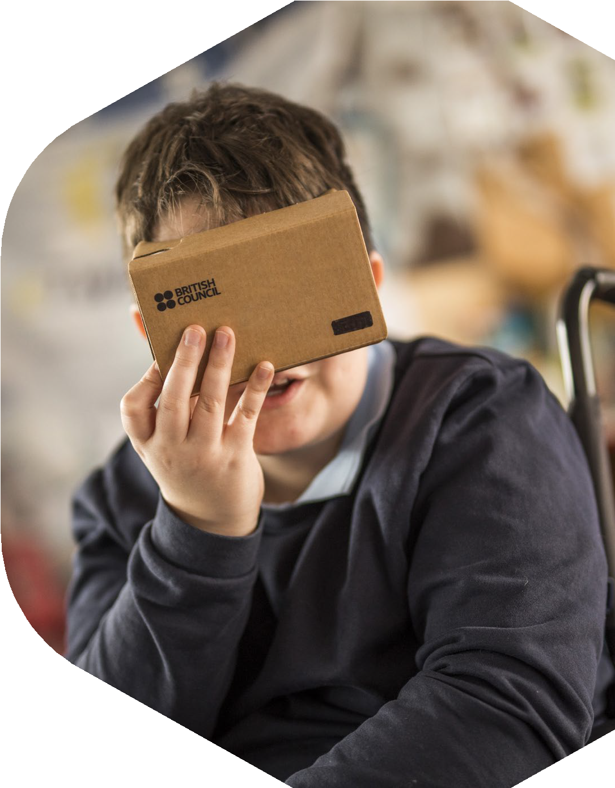

Being a teacher with disabilities: Perspectives, practices and opportunities 27

The focus on being self-reliant is exemplified in the experiences of the three teachers who had decided not to disclose their disability status to school authorities. Two of them were male teachers, and all had ‘hidden’ disabilities. For example, while Haniya from Jordan commented ‘I don’t tell anyone about my disability’, Gilberto in Brazil, who had ADHD, noted his strategic non-disclosure of disability when he indicated that:

I don’t like to identify myself as someone who have a disability, especially because I don’t like to see that I’m relying on some kind of ‘crutches’ … so I try to navigate the situation without disclosing my disability. So sometimes I have to deal with mean comments.

This echoed the experience of Pablo in Spain, a teacher with hearing impairment, who preferred to only disclose his disability ‘just informally’, primarily to students he taught. He repeatedly shared the belief that no change would happen even if he did share his disability with the school management: ‘it doesn’t really have any impact … it won’t make any difference. It won’t make a massive difference anyway.’

Teachers with disabilities as powerful agents for change
Despite all the challenges, a strong narrative of being a powerful role model for disability emerged in different ways among the participants. Most teachers (n=17) talked about how their presence and participation in school shaped students’ perceptions of inclusion and diversity. To enable students to reflect on human differences, Mar (Spain) included teaching materials that increased the visibility of disability, for example focusing on the actor Peter Dinklage who has achondroplasia (dwarfism), and the film Wonder, which centres around a child with facial differences. Mar’s story is captured in Box 3.

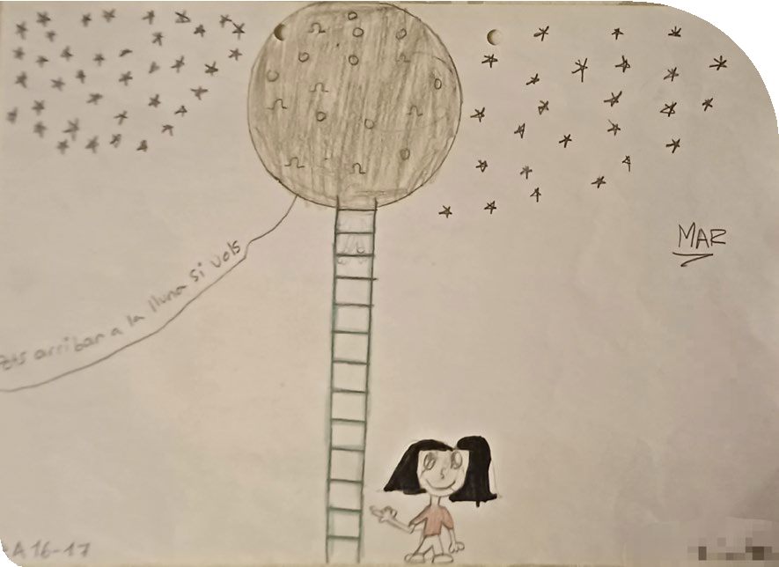
CASE STUDY BOX 3

Mar – Spain
Mar is a teacher from Spain with achondroplasia (dwarfism). She has 13 years of experience teaching English as a second language to children in the age range of
pre-primary to 12 years. She trained as a teacher after her experience of teaching clarinet to 6- to 7-year-olds, with the intention of ‘changing the world’ as she found it to be more ‘engaging, challenging and motivating’ than her previous role as a secretary. She strongly values the power of education. She feels ‘natural’ about having this disability and states ‘I wouldn’t have been who I am if I was taller’, even though she indicates that the ‘problem is more than the size’.
Mar is optimistic. She talks about how laws and authorities have changed for the better over the last 30 years. When she needs physical adaptations, she asks:

If I need something, I ask … And when I need help, I ask … I’m not shy to ask for help … The laws support inclusive teachers, the adaptations. If I need something, there are laws regarding that. I’m not asking something strange or something impossible.

Mar has very positive experiences of teaching younger children as ‘their minds are very open’ and completely different from a pre- teenager. She proudly shared examples of her students’ work, positive improvements and, with time, how students positively viewed her ‘… because in my teaching life when I get some of these presents, I keep with me and I keep in a very special part of my heart. This is a drawing …’ (Picture 1).

She also shared her ‘tricks’ for maintaining some ‘authority’ in the classroom. As an example, in a situation where Mar wants to ‘tell a student off’, she describes getting the student to sit down and having an authoritative conversation by ‘looking each other eye to eye, at the same level’. Further, she shared how she maintains a balance of authority, through a student’s description of her: ‘… her [teacher – Mar] behaviour sometimes is a bit … grrrrr … angry, but usually she is very friendly and very nice and funny’. Stating ‘but not everything has been wonderful’, Mar explained the more demanding, ‘testing’ experiences, such as a situation where students were caught laughing behind her back, and parents’ indirect indication of a lack of confidence and trust in her ability to teach their children.
However, Mar is well regarded by teachers and principals, and she states that they ‘treat me as any other teacher and they consider me as any other one’, explaining that, with time, ‘… they tell me, they forget my disability’. Using the term ‘positive discrimination’, Mar explained how she had had positive options in her career progression as a teacher with a disability, receiving opportunities to improve in her career like others and to try new avenues such as digital approaches in education. Mar strongly advocates for sharing experiences and making connections with teachers with disabilities from other countries and cultures, stating ‘they may have other tricks’, because often ‘the situation is the same’ everywhere.
She describes herself as a passionate, funny and creative person, telling students ‘If I enjoy myself, you will enjoy. If I don’t enjoy, you won’t enjoy. So let’s make it fun, amazing, in order for both to enjoy’.

Picture 1: You can reach the moon if you want (translation from Catalan) © Mar

Likewise, Lucia (Spain) also shared how her young students now see disability as ‘normal’ and ‘common’ through interacting with her. She added that it was really positive to make students realise ‘we are different, but we are together and we work together’ and that ‘to be disabled is not something strange’. Not only did the presence of teachers with disabilities foster acceptance but it also helped shape future aspirations of children who are more likely to believe in themselves and in their ability to overcome challenges. Mugisha (Rwanda) summed this up powerfully: ‘what I do, it will be a motivation for them’.
Pablo in Spain believed that ‘students are inspired by us whether or not they can identify directly’. And he felt that it was particularly positive for children with disabilities in these classrooms. He recounted how he felt a close connection with a student with autism, helping the student realise that no one is ‘perfect’.
Additionally, this also extended to helping children with disabilities develop some practical skills.
Uwamahoro (Rwanda) stated: ‘I give [them] the confidence in daily life’. She talked about how she actively helped students with hearing impairment to learn vocabulary, improve their writing and develop practical skills.
Apart from inspiring students with disabilities, when teacher training for inclusive education was not always available, Uwamahoro (Rwanda) was also advocating and advising other teachers at her school on inclusive teaching practices. Sharing a photo taken during the school’s weekly ‘communities of practice’, she explained that while the school had students with hearing and physical impairment, most teachers were not trained to cater for their needs. Picture 2, for instance, was ‘showing the difference between exclusion, segregation, integration and inclusion, it’s to show how to help learners in all classes of our school’ (Uwamahoro).

Additional gendered reflections
Given the near equal spread of participants in the sample – 14 male and 11 female – it is worth reflecting on any key seemingly gendered trends. It is important to emphasise here that these insights are rather difficult to generalise, given how gender intersects with the types of disabilities and, indeed, the socio- cultural norms in a given country context.
Additionally, the primary method of data collection was not a rigid questionnaire, rather semi-structured interviews, and through scaffolded questioning participants were encouraged to reflect and articulate their experiences. Nonetheless, some interesting tentative observations emerge in relation

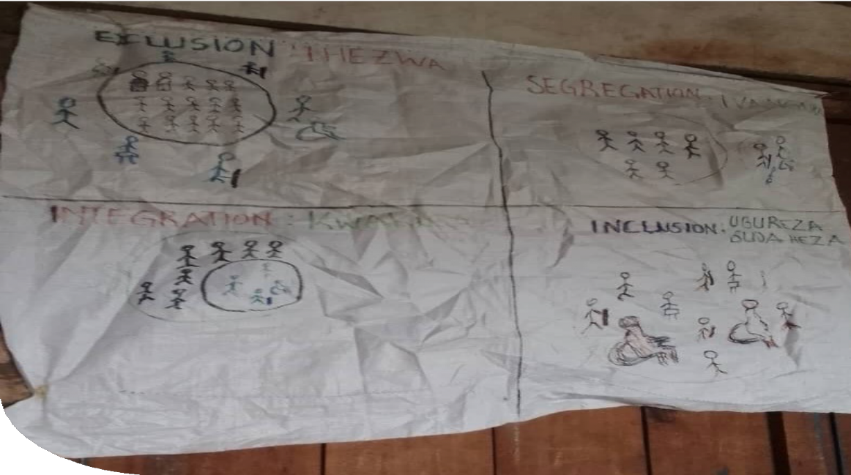
Picture 2: Showing other teachers about inclusive education © Uwamahoro

to the nature of interactions that teachers experienced. For example, based on a simple coding of the number of times teachers noted a positive interaction, it was evident that male teachers were generally more likely than female teachers to narrate enabling interactions with different members in the school. These included school leaders, fellow teachers and parents.
A relatively larger number of challenging instances were raised by female teachers, especially when engaging with school leaders and fellow teachers. In terms of participants’ experience with teacher training, a larger percentage of female participants reported having limited or no support in comparison to male participants.
More than half of the female teachers perceived that they had access to equal opportunities in career progression, compared to male teachers. The latter also reported negative experiences when seeking promotions. Thus, it is possible that women did not try for career progression, but their male counterparts did and were faced with challenges, resulting in their less positive perceptions of equal opportunities.

Strategies used by teachers with disabilities to function effectively in the classroom
Given that 18 out of 25 teachers noted having no to very limited support, it is important to explore how teachers fulfilled their different teaching responsibilities. The section below discusses the wide range of innovative strategies reported by teachers with disabilities to meet the multifaceted demands placed on them.

Being upfront about the disability: ‘I’m very open with them’ (Pablo)
To function effectively in the classroom, clear communication with the students about how this shaped their teaching style was seen as necessary. Five teachers across three countries (Jordan, Spain, Brazil) noted that it was important to be transparent with students about their needs, expectations and preferences. For example, Chadia (Jordan) shared that she had a respectful discussion with students around what behaviours would be considered as helpful in class, which resulted in students being ‘kind’ and ‘quiet’. For online teaching, Analu (Brazil) similarly provided simple but clear instructions to students so that they were aware of her needs. She mentioned at the outset that ‘you need to be loud. You need to speak up’. Pablo (Spain) likewise instructed students not to have multiple other conversations while he was teaching, or it would ‘mess me up, so don’t do it’. A snapshot of the strategies Pablo used are provided in Box 4.

CASE STUDY BOX 4

Pablo – Spain
Pablo is an English language teacher in an international school in Spain, where he has been teaching for two years or so. He teaches Years 7 to 11. He is completely deaf in one ear (it was a progressive loss of hearing) and has ADHD and dyslexia. He wears very small
‘in-the-ear’ hearing aids: ‘They are [very] expensive, but don’t really work very well. The only thing that they really stop is tinnitus’.
During the interview, he described how he could hear a loud noise in his head, like a whistling. If he puts in the hearing aids, then it is not that he hears any better, but the noise goes away and he can concentrate.
In the classroom, he is OK most of the time. He is very open with his students and tells them that ‘I don’t hear very well’. So, when one person is talking, there should be silence’. In his classroom he is very comfortable with the students, he is very honest with them about his disabilities and gives them clear instructions around how to best engage with him. For example, ‘if somebody has a question, I tell the entire room, “Let’s be quiet and listen to this question and answer it” ’. Being open has a ‘massive positive influence on the students who have those particular disabilities. And even, perhaps, wider spectrum issues’. It gives them the signal that ‘I’m not perfect. Not normal. So they say, “That’s OK. Mr. Pablo is weird so I’m allowed to be weird too”. And that’s quite nice. I like that’. This, he feels, is inspiring for students, whether or not they can identify directly with disability.
He has a very student-led teaching style and tends to provide them with a lot of information. Additionally, because of either his disability or the fact that he has more time (he does not socialise in school) or because of who he is, he feels that he tends to ‘know a lot more about my students and the subject than most of my colleagues’. This has given him a lot of confidence to do things his way and see his students reach their potential.

However, as soon as he goes outside of a controlled situation, it is just a ‘jumble of noise’. Given that schools are generally loud places, he can’t really function well, apart from in his own classroom. He reflected on how this prevents him from doing any other things in his job. He does not attend any meetings as they are not conducive to his needs. This is clearly having a significant impact on him, as he notes: ‘For this specific disability, it is pretty much the loneliness at work as a teacher’. He describes this:

You know problem is that, whenever there are teachers together, one-on- one, there are nearly always students there as well. So, there is background noise. And if it is quiet, and we are one-on-one, that is because one of us is getting somewhere and we haven’t got time to stop and chat. And so the only real time to meet and socialise
are the lunch times. And again, it is just too noisy. I just can’t speak to people there … which is a shame.

Pablo was an engineer for over a decade before moving into education, which he felt was more meaningful. However, given the very social nature of being a teacher – always talking and being in noisy environments – he is thinking of going back into the corporate world. Or as he describes:

Career progression is definitely moving out of mainstream education. Either into a different way of teaching like small groups somewhere else or consultancy, where you are much more one-on-one, or materials development or outside of school education into curriculum development for a company or something like that.

He has told the management about his disability but isn’t sure about what kind of support is available, or even possible.

32 Being a teacher with disabilities: Perspectives, practices and opportunities

Physical adaptations
Seven teachers focused on undertaking physical adaptations in the classroom to accommodate their mobility and hearing needs. Among these, four participants across three countries requested classroom reallocation. For instance, in Rwanda, Ganza taught in a school in a hilly area, where steep staircases and long distances between classrooms were very challenging. Hence, he requested a reallocation of the classrooms ‘just nearby so that I don’t move far distances’. In Sri Lanka, Chathura was similarly assigned classes closest to the staffroom, while Dayani did not have to move between classrooms, rather ‘students come to where I am’ (Dayani). Analu in Brazil, who has hearing impairment, was also relocated to classrooms that were less noisy. She noted that after discussions with the head teacher, the management were now aware of her need for ‘a quieter one [classroom], so I can focus on the students well’. At a school in Spain where a lift was available, Lucia managed to seek permission from school leaders to use the lift when she needed to lead students to move between floors. In her words, ‘she [the headmistress] decided that I could use the lift when my students are going up with another teacher [using the stairs]’.
Physical adaptations in the school, such as ramps, also featured in Lucia’s photo-elicitation (Pictures 3, 4a, 4b).

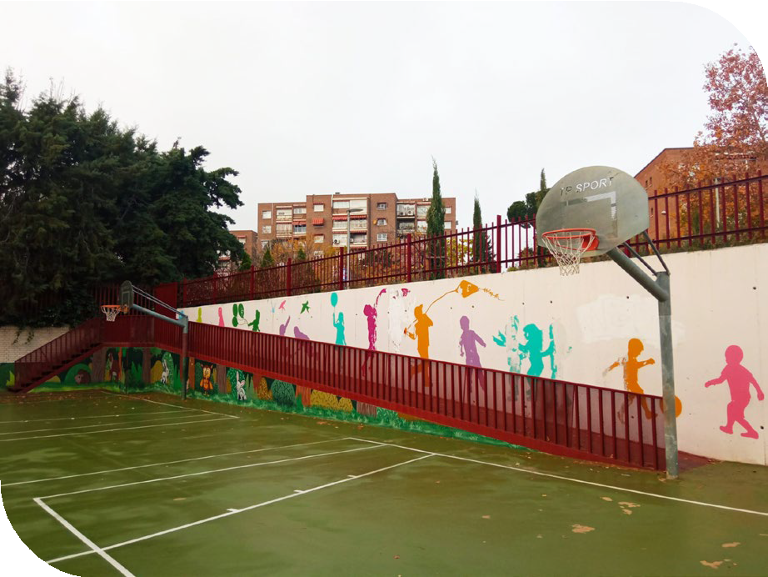
Picture 3: The ramp which I use to access to my school © Lucia

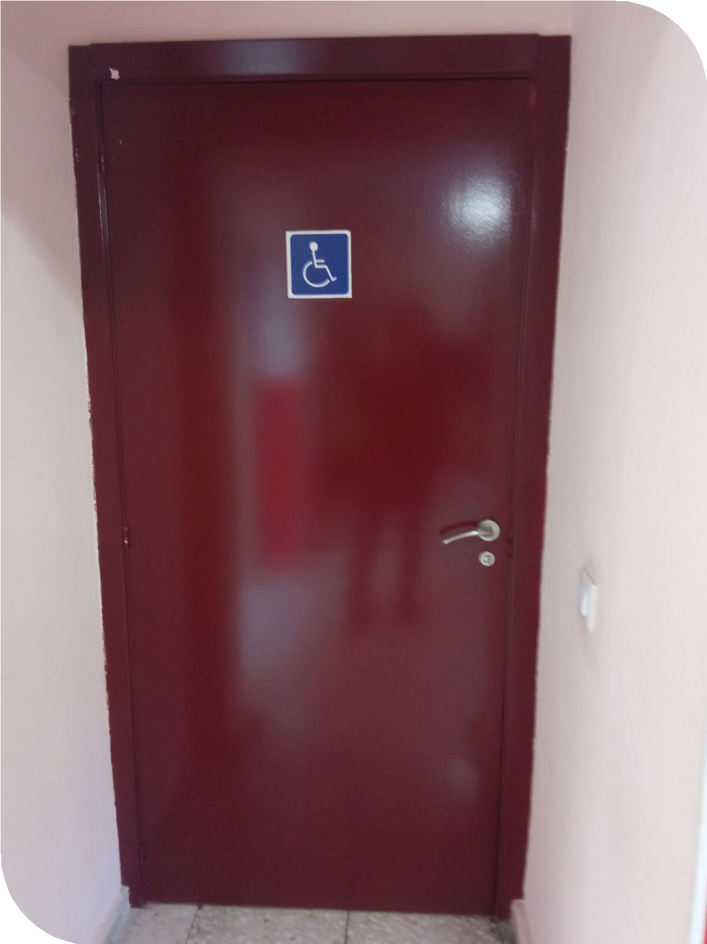

Picture 4a: The accessible toilet © Lucia
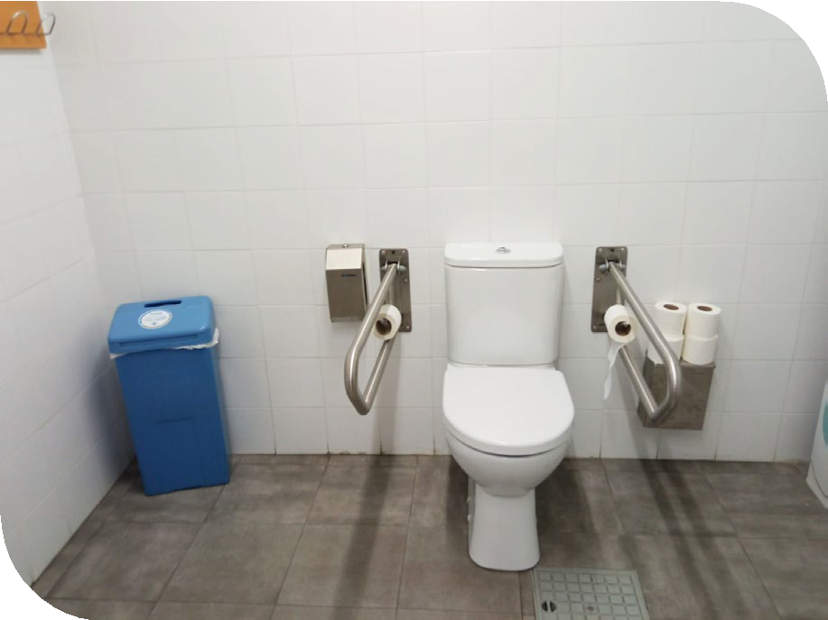
Picture 4b: The accessible toilet © Lucia
Mar in Spain explained how she ‘got a long step in the class to reach the screen or the board’, which she also captured in the photo-elicitation activity
(Picture 5).

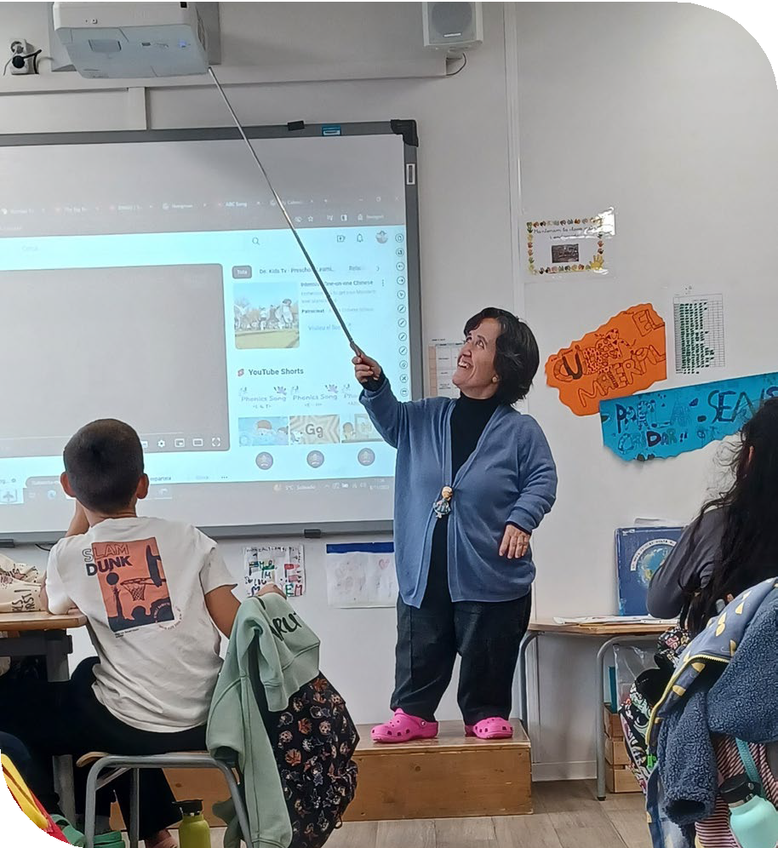
Picture 5: Teaching with the stick and big step © Mar
She noted how the step and stick helped her ‘to stand higher, be seen, reach all the children and be seen by all of them’. In the staffroom, Mar similarly was able to get her desk adapted (as shown in Picture 6). She described how a chair was tailored for her height, so that she could sit in a ‘good position’ without much strain on her back and legs.

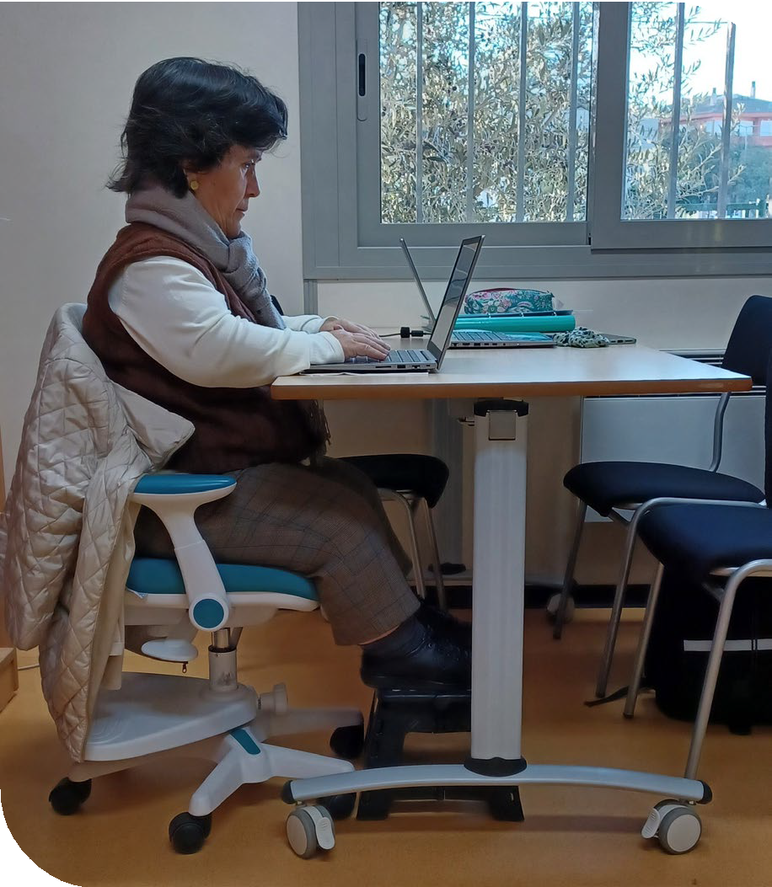
Picture 6: Preparing lessons on a special chair and step © Mar
Chaminda in Sri Lanka took a different approach from others and reduced his movement in the classroom:
I stand and say what we say. Some say to move around in the class and do some action. But from what I understand, a blind person can’t do that … Student don’t like us, just walking around and saying things. So, it is better to just stand in one place and say.

Preparing resources in advance
Three teachers, all with visual impairment, across Jordan and Sri Lanka described how they prepared teaching and learning resources well in advance. For instance, Amina in Jordan described that ‘I write things on cards ahead of lessons’, instead of having to write on the board. Having these cards allows her to display them to the students. Asiri in Sri Lanka shared a similar experience: ‘if I am going to give a small written note, I prepare it earlier and take it to class’. Chathura (Sri Lanka) drew on his social network to get materials prepared. He described how his wife, a graduate of media studies, helps him draw diagrams in advance, rather than his students missing out on seeing visual representations.

Students as teachers’ aides
Four teachers from Sri Lanka described students as valued collaborators during teaching sessions. For instance, Sanhitha’s students helped with identifying pages in the textbook: ‘when I describe an activity, they call out the page number’. Similarly, Chathura described how his students draw diagrams for him, since there are so many in his subject of media and communication studies. Two teachers described how they drew on selected students to do some tasks.
Asiri talked about how ‘I generally use a clever student in the class to help put materials on blackboard or with reading’. Likewise, Dayani described the role of ‘bright’ students in class, who could support ‘the things that I can’t do’, including ‘naming diagrams’ and ‘marking places on a map’.

34 Being a teacher with disabilities: Perspectives, practices and opportunities

Harnessing the potential of technology and assistive devices
Nine participants discussed how they harnessed the potential of technology and assistive devices. Three teachers with hearing impairment across three contexts described the usefulness of hearing aids (Pablo – Spain, Analu – Brazil and Haniya – Jordan): ‘my situation improved, and I began to communicate well, whether with my colleagues or with my students’ (Haniya). In addition to the assistive devices, the availability of videoconferencing platforms also enabled Analu (Brazil), who has hearing impairment, to adapt her teaching by transitioning from school into online teaching. She found communication mediated by the online conference platforms more accommodating for her needs. She drew a comparison between physical classroom and online teaching: ‘I can really focus and really concentrate on the sounds. I keep speakers on, with the aid of captions and subtitles, as well as seeing faces clearly’.
For reading text, six teachers with visual impairment across Jordan and Sri Lanka similarly found the use of Braille helpful. Latifa in Jordan described how she received a Braille-enabled laptop that she described as ‘very good’. Asiri and Sanhitha from Sri Lanka further highlighted using a scanner and subsequently specific software for reading text, which had made a significant contribution in accessing written material.
Technology was also found helpful to support teachers placed under extensive demands for writing. Six participant teachers discussed how they managed to replace handwriting by using ICT facilities, particularly projecting devices. For instance, Ganza (Rwanda) mentioned ‘I don’t even write on the blackboard. I just use a projector’ to display e-books on the screen for students to copy notes. Using typed notes, Buddika (Sri Lanka) talked about how it was possible to share these with students more easily.
Sanhitha, who is also based in Sri Lanka, shared how he was among the very few teachers who had significantly benefited from having ICT facilities, because these were only available in a very few schools in the context that had what are called ‘Mahindodaya labs’ (Picture 7).

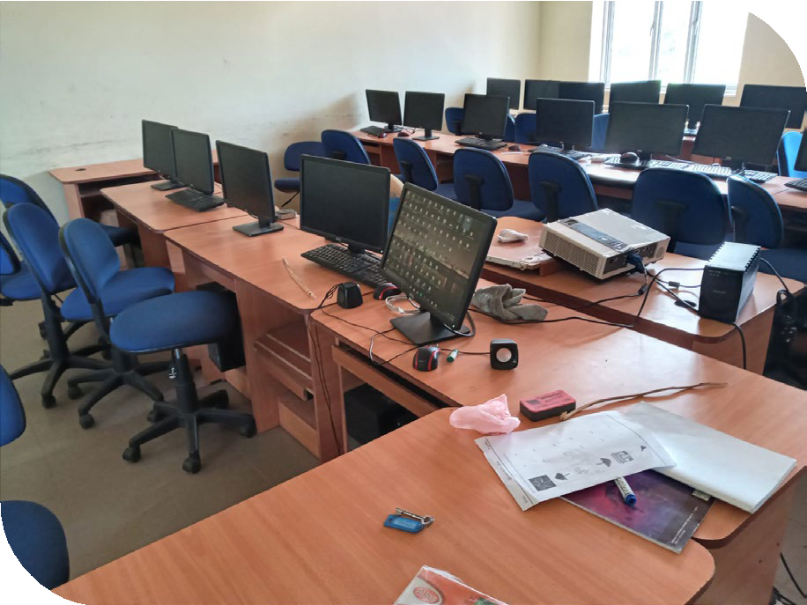
Picture 7: The ‘Mahindodaya lab’ in school © Sanhitha
Sanhitha described that having access to ICT facilities was for him not merely a simple solution to ‘ugly handwriting’ but also enabled him to be ‘an indispensable person’ with expertise in technology.
This meant that the whole-school community relied almost solely on him for technological support.

Providing additional resources for students
In terms of providing feedback, three teachers felt that their disability had impacted their capacity to have synchronous engagement with many students. With the constraints during lesson times, they found it helpful to provide additional resources after class. In Spain, Pablo, who has hearing impairment, described that he provided ‘a lot more information’ than his colleagues, with detailed explanations about the task and the rationale so that students could ‘read through it for themselves’. While Pablo was uncertain whether the exact reason was disability-related, he recognised a limitation that ‘during those discussions and tasks I can’t go to individual tables and help them’. Hence, he valued the additional provision as a compensation strategy. Similarly, Gilberto (Brazil), who has ADHD, noted that he assigned ‘a lot of written work’ to students and gave lots of individual feedback after the class. This is further elaborated in Gilberto’s case study (Box 5).

CASE STUDY BOX 5

Gilberto – Brazil
Gilberto, from Brazil, is a teacher with ten years of teaching experience. He teaches English and Portuguese at college level. Before beginning his teaching career, he worked as a social scientist for six years. He holds the Certificate in Teaching English to Speakers of Other Languages (CELTA) qualification and has recently completed a master’s degree in teaching.
Gilberto was diagnosed with ADHD approximately eight years ago. Prior to this diagnosis, he had experienced anxieties and difficulties in maintaining concentration over extended periods of time. He was dismissed from a teaching position for ‘speaking too slowly’ and ‘spacing out’. Additionally, he encountered challenges in attending to details. This once resulted in an unnoticed instance of bullying in his classroom. However, upon reflection, Gilberto expressed that this incident led to a fuller understanding of his condition and a desire to teach at a higher level. He then underwent a series of diagnoses at the local hospital in hope of identifying the underlying cause of the inattention he felt.
Given that ADHD is not a well-recognised disability in Brazil, even after the diagnosis Gilberto did not disclose his disability to others at work. This is because he does not wish to feel that he is ‘relying on some kind of crutches’. He also prefers not to be limited to an identity of someone who has a disability.
While he believes that his colleagues are generally helpful, he indicated that he has almost never asked for help: ‘My limitations can’t impact other people’s lives’. When reflecting on whether to continue ‘hiding’ his disabilities, his uncertainties linger. One particular worry is that there is a stigma associated with adults who receive a diagnosis of ADHD. Gilberto mentioned that society tends to perceive these adults as using the condition as an excuse to be ‘irresponsible’ and ‘ineffective’. On a practical level, he is also unsure how teachers with ADHD can be supported, so ‘You have to find ways … society is like that’.

Reflecting on his teaching experiences, Gilberto expressed a desire to continue with his own exploration of ways to remain self- sufficient, so that he could fit into society. He has rather minimal confidence or optimism that the system will change to accommodate the needs of teachers or people with disabilities.
He finds teaching large classes, in which he has to attend to and manage multiple events, difficult. He prefers to teach in a more student- centred style, such as by inviting students to participate in interactive classroom activities and letting them organise learning based on their interests. However, his preference had led to frustrations felt by some students who find a lecture style of teaching more conducive to their learning. Recalling some harsh and negative feedback he received, Gilberto regrettably acknowledged that ‘maybe I’m asking a lot from them [the students]’. Yet, he has also struggled to identify a pedagogical style that will work mutually well for himself and the students.
Addressing students’ comments and his teaching needs, Gilberto discussed his usual compensation strategy for not offering as much direct teaching as expected in class. He asks students to submit more written work for him to provide individual feedback. As a result, compared to his colleagues, Gilberto feels that he knows individual students very well by their names, writing style and handwriting. However, a dilemma remains. All the burden has fallen on Gilberto, who has to regularly work overtime to finish things such as marking, and he notes ‘it feels really, really tiring’.
Gilberto raises that to better support teachers with disabilities, mindset and awareness remain the key. For him, formal diagnosis of disabilities is crucial, but this should not be a prerequisite for people to respect each other: ‘when I talk about a diagnosis, there is a bureaucratic aspect to it. Like you need to have a paper to confirming that you are different to be treated respectfully’. Arguing for the need to see beyond disabilities, Gilberto hopes that society can be more accepting of differences.

36 Being a teacher with disabilities: Perspectives, practices and opportunities

Distribution of responsibilities among colleagues
Lastly, seven participants across all the countries shared how they collaborated with fellow teachers to share responsibilities when the assigned duties were beyond their capacity. In terms of supervising students for teachers with physical disabilities, Lucia (Spain) was given permission to split a 30-minute shift with another teacher, hence reducing the time she was required to stand in the playground. When supervising students during an excursion trip, Mar (Spain) requested a colleague to be the leader, and she was ‘the second teacher’. This enabled her to follow a more flexible and comfortable walking pace.
In terms of managing the everyday administrative duties, three teachers across Rwanda and Sri Lanka discussed how other teachers and support staff assisted them in different tasks. This included distributing materials to students (Ngoga, Rwanda) and managing the media unit (Dayani, Sri Lanka). In Sanhitha’s experience in Sri Lanka, when he was unable to access written documents, colleagues supported him by, for example, marking the daily attendance of students on the class register.
Specifically, within the classroom space, only participants from Sri Lanka and Jordan had reported extensive sharing of responsibilities with another teacher. For instance, in the subject of music, Chaminda in Sri Lanka elaborated on how another music teacher focused more on the theoretical side, while he focused on ‘the practical side’ by demonstrating how to play the instruments. He also shared that his colleagues’ support was crucial for classroom management, for example ‘to control the class’ when the class sizes were typically big, with more than 45 students. In Jordan, teachers with disabilities were systematically provided with teaching assistants. While participants from Jordan generally appreciated such practical support, this was not unproblematic. Notably, Chadia, who has visual impairment, drew on her teaching assistant for supporting classroom management and assessing students’ work. However, she also reflected that due to this reliance on teaching assistants, some teaching assistants ‘see me as someone less’.

Teachers’ experiences of teacher preparation and professional progression
Apart from their experiences at school and relationships with various members in the school community, we also reflected with participants on their experiences as teachers with disabilities during teacher training. We focused on exploring whether any adjustment or accommodation was made to support participants during pre-service and/or
in-service teacher training, as well as any subsequent opportunities for career progression within the profession. Across contexts, participants similarly reported having relatively few opportunities.

Experiences with teacher training
At the pre-service teacher training stage, 20 out of 25 participants reported receiving no specific support, across the five countries. For teachers with visual impairment, there were no documents available in Braille. For example, recalling his experiences, Asiri (Sri Lanka) stated ‘not even a single document was in Braille. So, we had to get someone else to read’.
Jordanian and Rwandan participants share similar experiences. ‘I had no support, no support for my disability’ (Uwamahoro, Rwanda). In Spain, Lucia recalled a particularly disappointing experience of exclusion that started from the pre-service teacher examination itself. The entrance to the examination hall that was specifically selected to gather all
pre-service teachers with disabilities was not accessible. She narrated the following incident:

When I arrived there [at the examination hall] I thought I was at the wrong place. Because there were too many steps just to go into the building and there was not elevator. I had to ask for help. I thought they [the authorities] would choose a new building with lifts for the exams, but they didn’t even realise it. They expected all disabled people to go and sit the exam in this building … I couldn’t believe my eyes.

For eight participants who reported receiving some support, this tended to be minimal and only after a lot of negotiation. For instance, in Spain, Mar described the adaptions as almost ‘nothing’ and were ‘little’, with little relevance. Most adjustments received by teacher participants in Sri Lanka were related to examinations only. For instance, Chathura recalled that teachers with disabilities were ‘assigned to a different examination hall, scribes were allowed to read the question paper, and given extra time’. In Rwanda, for Ganza, who has physical disabilities, while support was later provided, he described the frustrating process to convince the administrators: ‘they say “No, you are just joking … you can walk, and we see it”.’
Additionally, a few teachers acknowledged the crucial support they received informally from their personal networks and peers during teacher training. For instance, Latifa in Jordan highlighted ‘some of my friends and relatives supported me’. Pablo in Spain appreciated colleagues within the programme. In his words, ‘when I told people I can’t hear because of the noise, people were pretty accommodating in small groups’. Participants based in Sri Lanka felt that this placed a burden on their peers, who were also navigating various personal, family and wider challenges. For instance, Buddika noted that he ‘didn’t want to trouble another person’ who was already facing various problems. Yet he would need assistance from others to produce various lesson plans. He explained, ‘I could get another person’s help two or five times or more. But 200 times – how could I open my mouth and ask them to write 200 lesson plans for me?!’ With no other alternatives available, he dropped out of the postgraduate diploma.
Beyond personal networks, in Sri Lanka, four teachers also appreciated their lecturers for adjusting their teaching approach and the format of assignments.
For instance, on the former, Chathura noted that ‘they [lecturers] tried their best to deliver verbally in a way that we too could understand’. On the latter, Sanhitha found it very helpful when he was given permission to submit typed assignments rather than handwritten ones, while Buddika was also permitted to not produce the teaching aids that were otherwise required. In Brazil, Analu similarly appreciated her trainers for various adjustments through online platforms, which included adding captions and adjusting the lighting so that seeing lip movement could help her understand. Yet, these accommodations were made available from individual teacher trainers who did it out of goodwill, instead of being embedded in the training programmes.
In terms of participants’ experience with teacher training, more teachers with physical disabilities reported receiving little or no support compared to teachers with visual disabilities. This could be attributed to the severity of disability. For instance, Nkurunziza in Rwanda, who has physical disabilities, indicated that ‘my disability was not very high’. Over time, often after negotiation and self-advocacy, teachers with physical disabilities recalled receiving specific support. The change in support, in Mar’s experience in Spain, was attributed to the improvement of legal requirements. In her words, ‘the laws had changed and were more inclusive’. Four out of five teachers with visual disabilities who received support were from Sri Lanka. This was not attributed to any legal changes, rather driven by the willingness of their lecturers to meet individual needs. For instance, Dayani noted that the lecturers during teacher training:

gave us extra time to complete our tasks, as we take more time. Then they place us in front of the class, as we need to be listening to them [lecturers]. Also, they allow us to complete the work the way we prefer, in a way that is easy for us.

Notably, while teachers with visual disabilities were found to have more support from the school community and beyond, as well as receiving more support during teacher training, this did not necessarily relate to their perceived opportunities for career progression.

Progression pathways
When reflecting on the career progression pathways available to teachers with disabilities, 15 participants felt that due to their disabilities they were unable to progress in their careers or take on leadership roles. Asiri (Sri Lanka) summed up well the feelings expressed across the sample when he noted ‘there is no such a thing, actually’. Amina in Jordan had wished to teach at university level, but she was uncertain about the prospect as she highlighted that ‘some people are rejected because of disability’.
Other teachers were also less optimistic about the possibility of becoming school leaders, given the lack of accommodation and inflexibility within the mainstream system. Teachers with visual impairment in Jordan and Sri Lanka were particularly vocal in this regard. For instance, in Jordan, three teachers first highlighted the practical difficulties they face in performing the expected duties of school leaders: ‘You must have good vision in order to control all the situations’ (Chadia). Latifa and Amina likewise referred to the difficulties in filling in paperwork, and the same concern was raised by Sanhitha in Sri Lanka, who described that ‘vision matters’. In terms of managing discipline, Chaminda questioned, ‘I don’t have that ability. How can I control 1,200 [students]?’ In Spain, two teachers similarly doubted the possibility of becoming school leaders. Pablo’s account has been elaborated in case study Box 4. Similarly, Latifa (Jordan) pointed out that not all people can accept teachers with disabilities in management or
leadership roles: ‘they don’t believe we can do it, or we can participate, or we can do like what other teachers can do’. The level of discrimination perceived in relation to career progression was higher among teachers with visual impairments.
Ten participants, specifically those based in Rwanda and with physical disabilities, felt that they had equal opportunities for career progression. In Ganza’s words, currently the imihigo (‘performance contract’) signed by teachers with disabilities are ‘the same as that one of the persons without disability’. He believed that ‘they are not evaluating disability, they evaluate the performance’. For the two teachers with physical disabilities in Spain, this perceived equality was supported by the law.
For four teachers, the preference was largely for continuing in their current teaching role rather than progressing to higher levels. This was first attributed to the highly demanding managerial responsibilities. In Chadia’s words, ‘I don’t like these responsibilities, I like just teaching’. This is similarly shared by Chathura in Sri Lanka, who expressed that the classroom was a preferred space. In his words, ‘what I like the most is to be with the students’. Moreover, the structural barriers encountered by teachers with disabilities might also have led to adapted aspirations.
Highlighting the influence of the community, Dayani’s case study in Box 6 explains the decisions around her career progression.

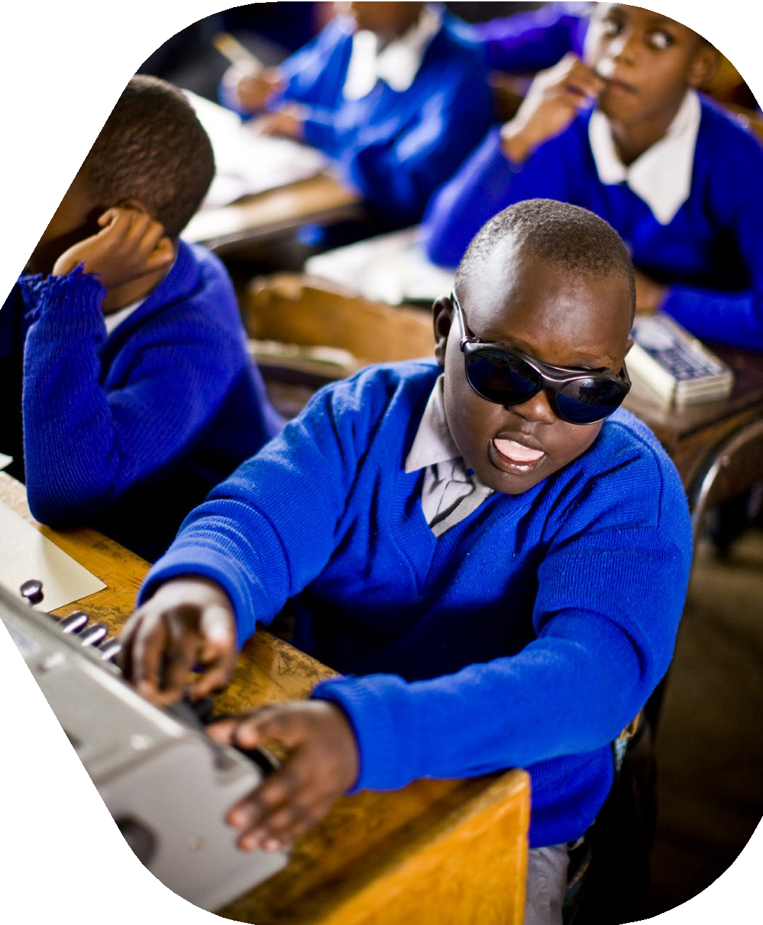

CASE STUDY BOX 6

Dayani – Sri Lanka
Dayani has been an Advanced-level history teacher for nearly 20 years, and is the teacher in charge of the school’s media unit in a mainstream school in Sri Lanka. She has been totally blind since childhood. She uses the Braille system, which she learned at the village school, where she is currently teaching. She is the mother of three children and the wife of a visually impaired husband, who is a social rights advocate. It had been her childhood dream of becoming a teacher or an announcer. She did not see her impairment as having any impact on her functioning, ‘I don’t have a big issue’, given that ‘everyone knows that I’m visually impaired, and students help me too … so I don’t have a problem’.
Dayani emphasises the value of being more ‘actively involved’ in school and initiating novel ideas that benefit the school, such as opening a media unit, through support from the management. She is in charge of the
day-to-day functioning of the unit in collaboration with another teacher. This includes the daily morning routine of chanting well-wishing stanzas (Jayamangala gatha) for the whole school, including the village (through loudspeakers), students reading the news, ‘thoughts for the day’, reading out letters and announcements, giving English or Tamil speeches, singing songs or reciting rhymes. She is actively involved in overseeing the planning and implementation of special announcements and programmes when teachers are retiring or being transferred, including planning the school’s annual year- end programmes. She provides training and practice to 26 Advanced-level (Grades 12, 13)

students who are enrolled in the media unit, for making public announcements in Sinhala, English and Tamil. To support her in these tasks, a non-academic staff member is assigned to her. She manages her teaching duties well through small modifications, such as students coming to her rather than her going to their classes; she does not use the blackboard, and specific tasks such as making and explaining diagrams etc. are given to students or other teachers.
Dayani talked a lot about the importance of having strong support systems at work and home. She explained, ‘There is nothing special. Everyone would take me everywhere, to the washroom, to the classes. Even the children take my hand and guide me. They don’t let me be on my own’. She emphasised a mutual interdependence by noting ‘that is because of the way I am with them. I support everyone at work, I talk to everyone, I don’t hurt anyone’s feeling. Hence these bonds, relationships and friendships are formed’.
She feels valued in school: ‘The principal doesn’t want me to go … Because if I leave, he says there is no one to fill my loss. Even the other teachers would not like me to leave’. She describes herself as a ‘very successful
woman’ and spoke about facing life ‘with great determination and supporting each other. I give support and get support from others. So because of that, my profession and my life has become successful’. She wishes ‘to continue to be in the teaching profession’, continue with her current tasks and remain in a school she is familiar with, as she does not have ‘an idea to go any further’.

Recommendations for promoting effective inclusion of teachers with disabilities
During the interviews, teachers were invited to reflect on the kinds of things that could be improved in order for them to have richer and more effective professional lives. Some of the insights emerging from this data are powerful.

Improving inclusion for all
Thirteen participants, across countries, recommended the need to improve inclusion for all people with disabilities, and not only teachers. This was discussed first around the need to remove barriers for inclusive participation in society. Mirroring the twin-track approach (combining disability mainstreaming with tailored support for individuals with disabilities), teachers recommended offering better inclusive services for all, and specifically promoting teachers with disabilities:

I think we have the right … I would like to work in the same conditions that my workmates do. (Lucia, Spain)

If I have my needs met [as a person with disabilities], I can teach well. When these are not met, I cannot teach well.
(Uwamahoro, Rwanda)

Two teachers in Sri Lanka provided concrete examples for improving everyday services, for instance they noted that people with disabilities are not given insurance. A similar belief applied to voting. Chathura described the reliance on an official or other village civil servant to cast a vote on behalf of a person with disabilities.
The argument being put forth by many of these teachers was simple – work on the basic needs and rights of all persons with disabilities, and this itself will be of benefit to them. Thus, focus on the inclusion of all persons with disabilities in wider mainstream society, while also undertaking disability-specific interventions to support the inclusion of teachers with disabilities in school settings.

Inclusive infrastructure for all
In terms of improving resources within schools and classrooms, 15 teachers across all countries raised the importance of policies and funding, which can enable all schools to be equipped with an inclusive infrastructure and teaching and learning resources. For instance, Ganza from Rwanda recommended that teacher allocation policies should consider whether the existing school infrastructure can meet their needs. He called this ‘a very big challenge’ when schools had insufficient resources for inclusive mobility, such as the lack of handrails on staircases. He talked about the lack of funds at the school level to address these basic needs. Similarly, Fadel (Jordan) highlighted the need for ‘accessible toilets, car parking spaces’, all of which were currently lacking.
Lucia (Spain) talked about how ‘most of the schools are very old-fashioned, like they don’t have lifts, you have to go up and down the stairs all the time’. The need to make the infrastructure inclusive for teachers will undoubtedly have a direct impact on improving accessibility for children too.

Enhancing financial support
Eight teachers, the majority of these being based in Rwanda and who had physical disabilities, talked about the need to improve teacher welfare, particularly around meeting their financial needs. When comparing to colleagues without disabilities, four participants from Rwanda and one from Jordan expressed their financial challenges when they felt unable to undertake other income-generating activities. Most of these teachers talked about the additional costs they had to bear in order to function effectively. For example, Shyaka from Rwanda, who needs crutches to walk around (see Picture 8), mentioned in his photo-elicitation activity how often these were unaffordable. He described this as ‘a big problem’ and wished that teachers with disabilities could be supported with mobility aids that were adapted to their needs.

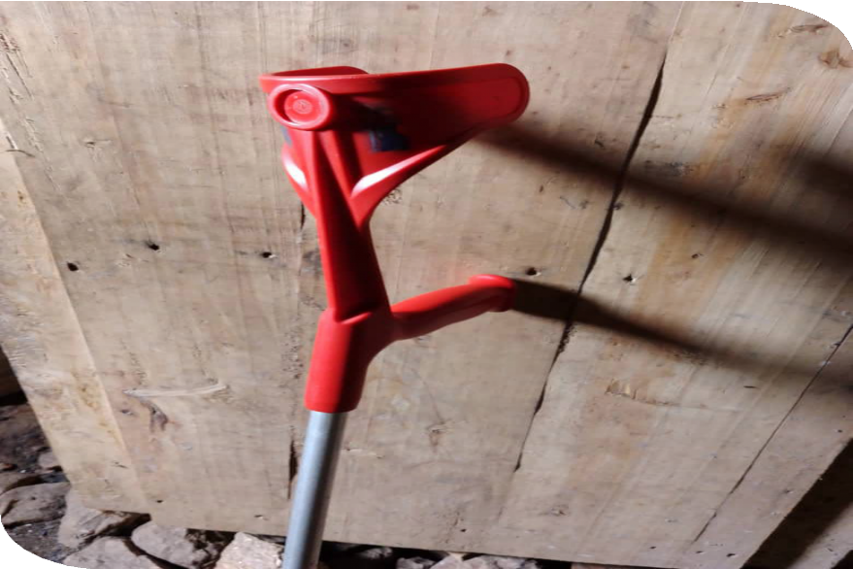
Picture 8: Photo of one of the crutches the teacher uses © Shyaka
Discussing various issues with her hearing aids (Picture 9), Haniya talked about the discomfort and inflammation she experienced and expressed her inability to buy new ones because of the costs.

Picture 9: Hearing aids that cause problems © Haniya
Four teachers recommended enhancing financial support to cover the cost incurred from using (private or public) transport. Keza (Rwanda), for instance, highlighted that financial support to attend medical appointments was needed. This was similarly raised by Nshuti (Rwanda), who is unable to walk long distances and discussed the need for a travel subsidy. In Spain, while teachers with disabilities receive free courses and tax benefits, Lucia described this

support as ‘only very, very, very little things’, and hence she strongly recommends enhancing systemic support for all.
The ‘extra costs’ of disability have been well documented in the literature, both at the individual and household level. It is commonly acknowledged that persons with disabilities have to divert part of their income to pay for specialist products and services, as well as pay for the basics. Thus, they must pay far more to achieve the same quality of life as their non-disabled peers. It is therefore not surprising that many teachers were raising these structural injustices and making a case for financial support through loans, subsidies, etc. to meet their basic needs to function effectively.

Equitable assignment of roles and responsibilities in school
Six teachers, across Jordan and Sri Lanka, recommended the need to assign roles and responsibilities equitably for teachers with disabilities. As teachers with disabilities are typically assigned secondary roles, in a teacher’s words, ‘I recommend that the teacher with disability should be in his [primary] position and call for another teacher just to help teachers with disability’ (Amina, Jordan). Similarly, Chathura in Sri Lanka raised the need for ensuring that all teachers be given timetables so that they have a more meaningful and legitimate role, beyond merely being ‘relief teachers’.
This is an important recommendation given that this research has highlighted how teachers with disabilities sometimes are not perceived as ‘real’ teachers, are assigned subjects that are not seen as integral to children’s learning and, in many countries, not given proper contracts.

Need for changing attitudes towards persons with disabilities: ‘Disability is not inability’ (Ganza, Rwanda)
Apart from the need for tangible improvements in terms of policy and infrastructure, 12 participants highlighted the need for advocacy. This was deemed crucial to improving attitudes towards people with disabilities and promoting inclusion. For instance, Gilberto in Brazil recommended a respectful and accommodating approach towards differences: ‘I think people don’t need a diagnosis to be respectful and attentive to other people’s limitations. People should be more accepting of differences’. Similarly, in Spain, Lucia talked about the need for empathy: ‘others need to understand how you feel when you have a disability’.
Noting the existence of a rather negative and pitying attitude towards people with disabilities in Sri Lanka, Chathura highlighted that society needs to move beyond ‘saying ane pau “poor thing”.’ Rather, non- disabled people need to understand that persons with disabilities have the potential to perform as well as others, and what is needed is to ‘support them to go forward’. Similarly, in Rwanda, Uwamahoro critiqued that the typical perception of people with disabilities is that they are ‘very poor’ and unable to do things, and this view needs to change.
Teachers felt that greater visibility of people with disabilities in the school curriculum, textbooks, media and other channels would make a significant positive impact:
In the field of education, very little attention is given to disability. In the school curriculum, if some component is included, it would be good. This will go a long way … it would have been good if we could teach Braille, sign language to the students who need it … actually all the students, just a little bit. (Chathura, Sri Lanka)

Training for school managers to understand the needs of teachers with disabilities
Addressing the attitudinal barriers and unfair treatment of teachers with disabilities at school, nine participants focused on the need to improve the attitudes of school leaders. Mandatory professional development programmes were recommended to better prepare school leaders for supporting disability inclusion. Specifically on addressing biases and promoting concrete understanding of inclusive practice at school, Latifa in Jordan recommended that before employing teachers with disabilities, all school leaders ‘need to learn’. Likewise, Dayani in Sri Lanka recommended the Ministry of Education to initiate similar programmes. She emphasised that with negative attitudes, ‘very little can be done’, when school leaders had other priorities over embracing the potential of teachers with disabilities. Currently, without such formal training, ‘it is only by associating people like me that they get an understanding’ (Chathura, Sri Lanka).

Inclusive teacher development opportunities
Addressing the lack of accommodation teachers with disabilities receive during their pre-service teacher preparation and for career progression, all participants made recommendations around the need to avail inclusive continuing professional development opportunities. Apart from recommending an increase in the frequency of regular training, teachers also similarly indicated the need for upskilling. Mar (Spain) noted that training is important to help teachers improve their self-confidence, while Mutoni (Rwanda) added that training would give a crucial boost to teacher motivation, if it was accessible. On top of skills for teaching, four teachers (Gilberto in Brazil, Mugisha and Nkurunziza in Rwanda, and Chadia in Jordan) also mentioned a desire for further studies to obtain certificates or diplomas that would enable them to teach at a higher level of education.
In terms of the content and focus of teacher training, four participants recommended a greater focus on disability inclusion. They emphasised the need for training in the practical side, to demonstrate how different teaching methods could be adapted to teachers’ needs and abilities. This would help teachers with disabilities function independently in their classrooms without relying on additional teachers or teaching assistants. In Jordan, Amina expressed a desire to learn how teachers with visual impairment could use different tools effectively as an alternative to writing on the board. In her words, ‘we need to be alone in the class, we don’t need some assistant teachers’. In Sri Lanka, Chaminda likewise recommended that teachers with visual impairment learn teaching methods that could work specifically for them. Similarly, in Rwanda, Mugisha wished to learn about a wider range of strategies to address the difficulty of teaching using activities or games that are not adaptable.
Moreover, five teachers also recommended training to upskill all teachers in using inclusive language and means of communication that would be helpful not simply for teachers with disabilities but also students with disabilities. For instance, teachers with visual impairment, such as Asiri and Chathura in Sri Lanka, discussed the need for Braille to be taught in school, to help support student independence. In Asiri’s words, ‘anything that we put on the blackboard or the whiteboard, if these can be given in Braille, it would be so much easier for us. If not, we depend on someone else’. This change would further need policy support in terms of embedding disability inclusion in the existing teacher training structure and school curriculum. While Chathura had initiated his own efforts to teach students Braille, he pointed out that ‘there is no time allocated to teach this officially’.

Investing in technological infrastructure
To address both individual and teaching needs, 15 participants similarly recommended further investment and improvement in technological infrastructure. Ngoga (Rwanda) captured the potential of technology by noting, ‘the best thing we have now is technology’. A few teachers discussed the need to increase access to laptop computers and an internet connection (Nkurunziza in Rwanda, Fadel and Latifa in Jordan). Teachers with visual impairment emphasised the role of projectors and smartboards in displaying content and materials, which could support teachers when handwriting was difficult. Apart from displaying content, technological devices also support teachers to use interactive pedagogy in supporting student learning. Fadel in Jordan thus similarly recommended the need to increase the availability of smartboards and tablets, which would be important to ‘exchange information with students inside the classroom’.
Two teachers in Sri Lanka also recommended technological resources to help them with ‘accessing new knowledge and teach’ (Dayani, Sri Lanka). Teacher Asiri went further and made an important point about context- specific needs. He noted how software used for reading texts can only be used for the English language and is insufficient:

… to read an English book, that could be done in some way. So once a page is scanned the software would read the text. We need to scan it page by page … well that is OK … at least there is some way. If someone actually develops an app or something to help read the Sinhala books, then it is very valuable … Now even in our professional life to read an official document, there is no opportunity for us to read when we want to. Having to rely on another person for this has been one of the biggest problems we have.

Chadia’s case study in Box 7 provides an account of her attempt at using technology in teaching.

CASE STUDY BOX 7

Chadia – Jordan
Chadia is a teacher from Jordan with an acquired visual impairment. With the initial dream of becoming a lawyer, she gradually moved on to being a teacher of English, as she felt English was not taught well. She has 17 years’ experience, working in a variety of settings.
Chadia had several insights into the benefits of technology. She explained the different technology-based strategies she incorporated into the teaching of English in her classes and extended it to home, bringing out her own strategies for teaching grammar and vocabulary:

I use video for example, we have something called horizontal integration, here, I connect our subject English with other subjects, when you want to talk about … let’s say the North of Jordan, then I ask the teacher of geography, the teacher of history to come and tell us about it in our language, to show them where it is
… Then I show them video to listen in English. I use a platform, specifically for me it is a classroom. I show them the video, I send it home, the video has some questions they have to answer after watching the video, and they can get marked, we can play games, lots of playing. They can tell me imaginary story … I made them something that is not easily forgotten. I don’t believe in teaching grammar in isolation.

Chadia sees technology as her strength. However, little knowledge of other important tools, such as smartboards, is something that she regrets, and she noted how it resulted in her losing a ‘big job at a big school which I had dreams of working’.
Her aspirations are heavily determined by what she thinks she is able to do or not do as a person with disabilities:

For sure I have disability, and I don’t have the chance to do a lot of things like being the headmistress. Deeply inside I don’t like these responsibilities, I like just teaching … I believe in being a trainer, this is my dream … Being a headmistress would be something difficult for me as a person with disabilities.

As a teacher, classroom management – given that there are 35 to 40 students in the classroom – is a challenge. She does get support through the Ministry, as she is provided with an assistant. However, she raises important issues around social awareness and acceptance of persons with disabilities: ‘So the principal asked the Ministry of Education to offer me an Assistant Teacher and it’s one of my rights. But I have problems, dealing with them, they see me as someone less’.
Despite all the challenges, Chadia is confident about her abilities:
I believe in myself, I trust myself I can do a lot of things … I see myself as a creative teacher. Even with my disability, because my students are improving, or developing. I develop my students, I affect my students.

Networking and building communities of practice
When discussing whether participants were connected to other teachers with disabilities, the majority (17 out of 25) highlighted the scarcity of opportunities and networks for this purpose. Only three teachers (Ganza in Rwanda, Chathura and Sanhitha in Sri Lanka) discussed extensively various networks they are involved in or benefit from that target people with disabilities in their respective countries. Yet these connections were valued. For instance, Amina in Jordan described it as ‘very useful’ when she spoke to her friends who shared similar conditions, ‘because the problems are similar, we discuss some solutions for our problems’.
However, only two participants (Chadia in Jordan, Pablo in Spain) had colleagues with disabilities within the same school, while other participants shared that they had limited or no interactions with other teachers with disabilities.
Five teachers across Brazil and Spain were particularly vocal about this issue. For instance, in Spain, Lucia recalled meeting other teachers with disabilities only during the teacher entrance exam, while Pablo described the professional isolation as ‘loneliness at work … I don’t think I know any teacher socially at all’. Without much peer support, he had considered leaving teaching after having gone ‘as far as I could go in mainstream teaching … and it is just a job, then there is really nothing keeping me here’ (Pablo, Spain). Similarly sharing the feeling of being ‘alone’, Mar in Spain described that while she knew other people who shared her type of disability, ‘it is difficult to find, to come up with other teachers with disabilities. There is no kind of network to be in touch with other teachers with disabilities.’
In recognition of the value of forging closer connections among teachers with disabilities, these participants advocated for future initiatives to develop alliances within and across countries to foster communities of practice. These were envisaged as enabling teachers to identify shared experiences and practice, strengthening self-advocacy and learning about possibilities of change through collective action. Mar (Spain) noted that such a network would be ‘motivating’ and she would be ‘proud to be a part of it and to share my life with others’. Similarly, in Rwanda, Nkurunziza recommended the development of more circles and centres ‘to share ideas as people who live with disabilities. This means that there can be something done for them’. Ganza’s (Rwanda) story in Box 8 captures the power of self-advocacy.

CASE STUDY BOX 8

Ganza – Rwanda
Ganza is an experienced teacher from Rwanda, with 19 years of teaching experience. He has been teaching English (for Ordinary level), and general studies and communication skills (for Advanced level) at a secondary school in Kigali. Polio impacted him at a young age and led to paralysis of his right leg, significantly impacting his day-to-day mobility. For any commute beyond the school, he relies on hired pillion motorcycle rides. This has not only posed risks to his health and safety owing to heavy traffic and poor road conditions but is also a substantial financial burden, given his low teacher salary. All this has a significant impact on his health and well-being, and that of his family.
Ganza initially did not intend to become a teacher: ‘I never intended to become a teacher but just, I just found myself in that career and I just loved it because of what I found’. Later he found the profession valuable and enjoyable, as it gave him the opportunity to continually update himself with new knowledge and the chance to make changes in real-life settings. Ganza is a strong advocate and takes responsibility for bringing about change in his circumstances. He noted that nothing would have happened without his
self-advocacy. First, he was not allocated on-campus accommodation at the teacher
training institute. He recalled that ‘the one in charge [of accommodation] was asking me “Why do you need accommodation?” … someone cannot recognise I have a problem of disability’. When Ganza tried to explain his needs, the administrator ‘thought I was just joking’. In school, likewise, the management did not consider his mobility needs and did not assign him classes on the ground floor. He managed to get a classroom with a projector and laptop to reduce the need for handwriting on the blackboard.
He also recalls many unaccommodating experiences that made him feel humiliated. When he was still a student, he was

uncomfortable with the school rules that made short trousers compulsory as part of the school uniform. In his words, ‘I put on short trousers and this one [leg] is smaller than this one [the other leg]. I felt that I am not like others. I am not fitting into the society, and I decided to leave the school’. As a teacher in his current school, he describes his colleagues as respectful and kind, but also mentioned instances of disrespect he has experienced, primarily shaped by negative experiences in society. Apart from being rejected from a job at an early stage of his career because of his disability, he observed that some students often laugh at him or look at him in a particular way due to his disability. However, over the years, ‘I have accepted myself’. Inspired by his own trajectory and ability to self-advocate he is determined to draw actively on his lived experiences and help others.
As the only teacher with disabilities at his school, he regularly serves as the first point of liaison between students with disabilities and the school administration. With his intervention, a few students with physical disabilities have been allocated places at the boarding section of the school to minimise travelling to school. He has also been able to get accommodations for examinations, for example a student without arms was able to get a scribe to help with the writing of his exam papers. However, he notes that a lot more must be done to support both teachers and students with disabilities, especially those with multiple types of disabilities. ‘They are talking about inclusiveness but there are some children … they are not fitting into any category, you find that there is no school where they can fit,’ said Ganza. As a result, he is actively involved in advocacy efforts. He is positive about the progressive improvement the country has made to support people with disabilities, especially in legislative areas.
However, many complexities remain before fully realising the spirit of inclusion for all.

Research as empowerment
Teacher participants unequivocally expressed their appreciation for having had the opportunity to discuss and reflect on their professional lives. Notably, four participants indicated that teachers – particularly teachers with disabilities – rarely have their voices heard or valued. They appreciated it because it was the first time they had had the space to speak up and reflect on their lived experiences without judgement. For instance, despite repeatedly encountering unpleasant experiences and injustice at various levels, Gilberto (Brazil) indicated that ‘I have never actually talked about it … this is actually the first time I have put my ideas in order in relation to this topic’. He found this very helpful for deepening his reflection. Likewise, in Spain, Pablo appreciated the reflective conversation that ‘helped me think about my own context’, while Lucia further expressed her thankful surprise to realise that people with disabilities ‘matter’ – ‘I think disabled people don’t matter for anyone.
Only your family or your friends. So when I read the advert, I said, OK I have to be there. I want to speak out’.
Moreover, all participants similarly valued this research for its potential to initiate context-relevant changes at both system and individual levels.
Buddika (Sri Lanka) began by acknowledging the importance of documenting not only anecdotal but shared experiences of ‘how we [as teachers with disabilities] are really treated’. Mar (Spain) highlighted that ‘sharing with others is always a good opportunity and enrichment for each other’.

These narratives are highly empowering, but also highlight the need for research such as this to be used actively for advocacy and change, especially when the inclusive education agenda has overlooked the role and need for an inclusive education workforce, particularly from a disability perspective.

Being a teacher with disabilities: Perspectives, practices and opportunities 49

Country overviews

Brazil
There is a significant lack of visibility of teachers with disabilities in the official documents that were reviewed for this project and in relation to research evidence. Despite numerous efforts, such as circulating the recruitment poster through British Council offices and other social media platforms, only two participants came forward to participate from Brazil. Both teachers have contrasting disabilities and life stories, and were teaching a variety of subjects, including English. The key themes that emerged from the two participants were multiple instances of exclusion from and within the formal structures of education. The female teacher with hearing loss had left the mainstream school, given her inability to cope with noise and the lack of adjustments that were offered. The male teacher with ADHD struggled with his disability identity – being aware of it, but not wishing to emphasise it, and mindful of the fact that he believed that it was not recognised in Brazil. He talked about the significant number of student complaints that he had to deal with regarding his style of teaching, as he did not feel comfortable in big groups and lecturing. He talked about isolation in school, rising from not being able to connect with his colleagues. What emerged across these reflections was the significant onus of the responsibility to perform effectively as a teacher being placed on the individual, with little or no structural support.

Jordan
Among the countries selected for this project, Jordan stands out as the only country that has explicit reference to teachers with disabilities in one of its official documents. In the 10-year strategy for inclusive education, which is co-developed by the Hashemite Kingdom of Jordan Ministry of Education and the Higher Council for the Rights of Persons with Disabilities, nine strategy components are identified. Teachers with disabilities are recognised under the sixth component on ‘Human Resources and Capacity Building’, who will be recruited to design and deliver training in inclusive education. This demonstrates a clear commitment to promoting support for teachers with disabilities, not only in teacher training but also changing ‘behavioural attitudes towards inclusion’ (MoE-Jordan & HCD, 2020: 29). However, the five participants from Jordan (four with visual impairments

and one with a hearing impairment) expressed significant challenges when teaching in mainstream education. Teachers noted unpleasant experiences to varying extents with school managers, other teachers and students. This was largely due to a lack of awareness of disabilities and limited exposure among wider society to the lived experiences of people with disabilities. All of them noted that others expressed doubts about their ability to teach, a concern that was not related to their subject knowledge of English. This resulted in an interesting scenario where even though the system formally provided teaching assistants (TAs) to support teachers with disabilities with various duties, participants noted how this arrangement resulted them in being looked down upon by the TAs themselves and they were unwittingly relegated to the role of extra teacher, whose abilities were not fully recognised.
Reflecting on what may support their teaching and career progression, participants expressed a desire to challenge the prejudice embedded in wider society and appreciated the role of technology. Smartboards, projectors and Braille-enabled laptops were cited as examples that could support teachers with disabilities in delivering lessons effectively. Additionally, participants strongly emphasised the need for financial support to attend training programmes to obtain further English qualifications and improve teaching skills. These efforts, among others, were seen as crucial to ensuring that teachers with disabilities could function independently in their classrooms.

Rwanda
Despite Rwanda’s strong commitment to inclusive education, there has been limited focus on teachers with disabilities in official discourse. This lack of visibility of teachers with disabilities was confirmed in an interview with a senior education official, who talked about the lack of any official provision. All nine Rwandan participants had physical disabilities and were primarily men. The impact of their impairment on their classroom teaching was less pronounced, but they faced major mobility challenges both within and beyond the school. A key theme emerging from participants’ accounts was the largely positive interactions with all members of the school community, particularly school leaders. For instance, a few teachers indicated that their school leaders ensured that teachers with disabilities were not being discriminated against and were treated the same as other teachers without disabilities. However, all

50 Being a teacher with disabilities: Perspectives, practices and opportunities

participants also consistently spoke about the limited formal support they received across their career stages, from teacher training, working at school, to career progression opportunities. Looking towards the future, participants emphasised the need for greater material support, given that all of them noted a disproportionate impact of their disability on their financial resources. For example, most had to avail expensive transport for their commute to school due to mobility issues, and this was having a significant strain on their financial resources. All the teachers hoped for schools to be better equipped with pedagogical resources such as textbooks and computers, so that they could provide notes to students without relying on writing on the blackboard. Personal support such as mobility aids and direct financial assistance was also very much welcomed.

Spain
The number of persons with disabilities entering higher education in Spain is higher than other countries reviewed. Nonetheless, there is little information about their participation in the education workforce. Despite numerous efforts at recruiting participants for this study through the British Council’s country office and other social media platforms, only three participants came forward to participate. All three were teachers of English, in addition to other subjects such as digital communication and Spanish language. One teacher taught the early primary years, while the other two taught primary and secondary years. All three had different disabilities, ranging from physical difficulties in functioning, such as an acquired lower limb paresis and achondroplasia, to a severe acquired hearing impairment. The key themes that emerged from two of the three participants were around stories of exclusion from and within the formal structures of education, resulting in limitations in performance and motivation to progress in the profession. However, the female teacher with a developmental disability of achondroplasia (dwarfism), spoke at length about how formal legislation and the accommodations she received as a student and as a teacher had helped her to work effectively. In this process, she also highlighted the strong sense of self-advocacy and
self-determination she nurtured. In contrast, the two teachers with acquired disabilities remained ‘lost’ in the system, with one (female) ‘waiting’ for a formal diagnosis and in the meantime making informal requests for accommodations, while the other teacher (male) seemed to be progressively withdrawing from the system, as he struggled to manage himself and did not wish to make informal demands. Emerging from these three narratives was the stark contrast in how the type of disability created completely contrasting experiences of being a teacher for the three participants.

Sri Lanka
In Sri Lanka there is a significant lack of visibility of teachers with disabilities in official documents and in research evidence. Six participants (five male and one female teacher) all had visual impairment and were teaching a variety of subjects, such as music, Buddhism, ICT, media and communication. A consistent theme that emerged in their accounts was the notion of being a peripheral teacher – many spoke about not being given formal teacher duties or having been asked to teach subjects that were regarded as peripheral to the more serious ones.
While personal motivation and grit got them through their training, they lamented the significant lack of necessary provisions and adaptations to continue their daily work or make any progress in their careers. The knowledge about and attitudes towards disabilities among gatekeepers, particularly school principals, was a significant determinant in how included (or excluded) the teachers felt and what opportunities were available to them to perform their roles. Also highlighted by the research participants was the immense value and significance of informal support systems, such as their immediate family, friends, colleagues and, in some instances, community. For example, those teachers who were teaching in their neighbourhood school had many positive experiences with the community. In the absence of little or no formal support, these teachers persevered in a mainstream education system that basically kept them at the margins.

Being a teacher with disabilities: Perspectives, practices and opportunities 51

SECTION 5

Next steps

Based on the review of national policies, academic literature and empirical research conducted with teachers with disabilities across the five selected countries, we found that there is a strong scope to improve inclusion of teachers with disabilities across all career stages. This requires changes at different levels in the system, including strengthening national policies and legislation, implementing inclusive teacher recruitment and training pathways, equipping schools with appropriate teaching and learning materials and also raising disability awareness among school leaders.
In consideration of the evidence gathered from this research, this report makes the following recommendations for next steps.

Recommendations for national governments
Develop clear recruitment policies for teachers with disabilities. While most governments have very strong general policies to recognise the rights of people with disabilities in employment, this is insufficient in addressing the needs of teachers with disabilities specifically. There is a need for national governments to develop, strengthen and prioritise clear official pathways for the recruitment of persons with disabilities into the teaching profession. Clear guidelines should be provided to ensure that there is consistent understanding of the responsibilities and roles of teachers, including those with disabilities.
This is to ensure that all qualified teachers are recognised in the school and that teachers with disabilities are seen as equal professionals, cognisant of their qualifications and training.
Invest in inclusive teacher training programmes. This is crucial given that this is the first experience that many persons with disabilities have of the education system from a service provider perspective, rather than a user/student perspective.

This would mean structurally having the resources to make accommodations and adaptations to the training programme, including in its delivery, assessment processes and pastoral care. These may include the provision of technology to support classroom engagement; adopting inclusive assessment strategies so that teachers with disabilities are able to seek higher qualifications; and provision of bursary schemes that could offer financial support to trainees who are in need due to their disabilities, for example for the procurement of devices and/or to meet the extra costs arising from their disability.
Moreover, there is a need to ensure teacher trainers and any facilitators of professional development programmes are sensitive to the needs of teachers with disabilities attending these programmes, such as the types of inclusive practices or adjustments for different types of disabilities. Embedding inclusion in teacher training programmes can be a helpful model for non-disabled trainee teachers to understand ways to support inclusive pedagogy in their classrooms in the future.

Empower school leaders to make flexible decisions. School leaders should be supported and monitored to support teachers with disabilities to perform their duties. Including a disability awareness training component in head teacher training programmes, which provides them the opportunity to acquire the necessary disability-sensitive attitudes, knowledge and skills, would be a useful way forward. While ideally all schools should be equipped with an inclusive physical infrastructure and technology such as computers and projectors to support teaching, this may remain a practical challenge across low- resourced contexts. Thus, school leaders need to be empowered to make person-specific adaptations for inclusion-related needs. This may include reallocating existing school budgets, sharing resources with other schools and making internal arrangements such as encouraging teachers to share responsibilities collaboratively. This is also crucial in developing an inclusive whole-school culture.

Recommendations for educational programme design
Recruit teachers with disabilities in all programmes. Organisations designing and delivering education programmes can play a very important role by spearheading the inclusion of teachers with disabilities in their programmes. These programmes need to acknowledge and prioritise the specific needs of teachers with disabilities. This will assist in embedding the inclusion agenda in mainstream settings and enable all stakeholder groups to recognise the abilities of teachers with disabilities.
Mandate disability-awareness training. This should apply to all programmes that are implemented, to ensure that people who are delivering these different programmes are sensitive to disability issues and can model good practices. Equally, it would be significant to consider the development of disability awareness and training for schools and teachers. These ideas can be effectively developed not only as a stand- alone programme on disability but as a more comprehensive module addressing inclusive teaching practices, hence looking at intersecting variables, such as gender, ethnicity, etc.
Build the capacity of teachers with disabilities to use EdTech. Teachers with disabilities often feel unprepared and lack confidence teaching with technology, hence their capacity needs to be built (and that of others in the school). This could involve an individual-based approach, wherein the aim is to cater for specific individuals’ needs, or it could also include a whole-school approach. The latter could mean assessing the existing technological infrastructure and capacity of schools and teachers, and then taking ownership of any technology that is deployed, while ensuring that the technological interventions are most useful to those who are at the greatest risk of being marginalised. For example, interactive smartboards can be incredibly useful for many teachers with disabilities who have difficulties writing on the board. However, their potential as a pedagogical tool can also be harnessed by ensuring that all teachers in the school are trained how to use these effectively, hence having benefits for all teachers (and students).
Provide professional mentors to teachers with disabilities. This could be persons with disabilities themselves or those irrespective of their disability status who are strong advocates. These mentors could be important in ensuring that they, if need be, advocate for teachers with disabilities. They can also draw on their own experiences to help teachers with disabilities perform effectively in their classrooms, by sharing pedagogical approaches and assisting in implementing various accommodations and adaptations. A systemic assignment of mentors is also important in recognition of the lack of social network and professional support for teachers with disabilities, who are most often isolated within their school. Thus, accessing mentors is important to ensure that teachers with disabilities have a safe space for
non-judgemental conversations with an experienced person to help them navigate the challenges in school and beyond.

Being a teacher with disabilities: Perspectives, practices and opportunities 53

Draw on the convening power of educational organisations to undertake multiple stakeholder consultations. Additionally, this can also help develop international accountability mechanisms, which can offer a way to strengthen the implementation of policies, programmes and legislation for teachers with disabilities. This could mean that when designing teacher training programmes, stakeholder consultations could be facilitated, which should include teachers with disabilities. Since inclusion requires a whole-system collaboration, it is important to ensure that all involved stakeholders have a shared understanding of their roles and responsibilities and that there are strong accountability mechanisms in place, while also ensuring that multiple stakeholders’ interests and perspectives have been factored in. Another key stakeholder group to engage with would be teaching unions, who have remained largely silent on issues impacting teachers with disabilities.

Recommendations for programme monitoring, evaluation, research and learning
Develop multilevel and multistage approaches to change. Inclusion is an ongoing process. It requires an effective plan that defines impact in more sustainable terms across programmes that go beyond a single intervention. Externally funded programmes or interventions tend to be rather short-lived and do not sufficiently empower the local communities to draw on their rich resources and networks to support teachers with disabilities. Hence, building on the mentorship programme mentioned above, one
longer-term impact could be to build communities of practice (CoPs) for teachers with disabilities across the different programmes and contexts. Multiple common themes of exclusion of teachers with disabilities from and within the system emerged in this research. CoPs can encourage supportive conversations around the needs of teachers with disabilities, which can also foster skills-building, collate good practice and stimulate innovations. This will also empower teachers with disabilities to become active pioneers of change rather than passive recipients of support.
Carry out more research with a specific focus on disability. Future programmes should consider collecting disaggregated data on the disability status of teachers. Additionally, for all participants enrolling in different programmes, information on the desired accommodations and adaptations required and the kind of support offered should be gathered. This will help organisations to develop a disability-focused toolkit to collate good practice, which can be used to facilitate future programme designs. This data can also help develop evidence-informed policies and programmes for the wider education sector.
Work with teachers with disabilities on impact evaluation. There is a need to acknowledge that teachers with disabilities are experts in their career experience and advocacy for inclusion. Future research and evaluation can consider going beyond researching on teachers with disabilities as participants, to collaborating with them to design cycles of evaluation of whether these programmes have successfully addressed barriers to disability inclusion. This will help to provide more nuanced perspectives on both the opportunities and the challenges to change.

References

Anderson, R.C. (2006). Teaching (with) disability: Pedagogies of lived experience. Review of Education, Pedagogy, and Cultural Studies, 28(3–4), 367–379. doi:10.1080/10714410600873258.
Antilla-Garza, J. (2015). Embodying justice: Supporting teacher candidates with disabilities. AILACTE Journal, 12(1), 73–91. https://eric.ed.gov/?id=EJ1092025.
Antoninis, M., April, D., Barakat, B., Bella, N., D’Addio, A.C., Eck, M., Endrizzi F., Joshi P., Kubacka K., McWilliam A., Murakami Y., Smith W., Stipanovic L., Vidarte R. & Zekrya L. (2020). All means all: An introduction to the 2020 Global Education Monitoring (GEM) report on inclusion. Prospects, 49, 103–109 . https://doi.org/10.1007/s11125-020-09505-x
Bellacicco, R. & Demo, H. (2019). Becoming a teacher with a disability: A systematic review. Form@re – Open Journal Per La Formazione in Rete, 19(3), 186–206. https://doi.org/10.13128/form-7720
Bellacicco, R., Ianes, D. & Macchia, V. (2022). Teachers with disabilities: A systematic review of the international literature. Form@re – Open Journal Per La Formazione in Rete, 22(1), 64–88. https://doi. org/10.36253/form-12138
Braun, V. & Clarke, V. (2012). Thematic analysis.
American Psychological Association.
Brulle, A.R. (2006). Teacher candidates with disabilities: Guidance for teacher educators. Action in Teacher Education, 28(3), 3–10. doi:10.1080/0162662
0.2006.10463415.
Bryant, L.G. & Curtner-Smith, M.D. (2008). Impact of a physical education teacher’s disability on elementary pupils’ perceptions of effectiveness and learning.
Adapted Physical Activity Quarterly, 25(2), 118–131.
Bryant, L.G. & Curtner-Smith, M.D. (2009a). Effect of a physical education teacher’s disability on high school pupils’ learning and perceptions of teacher competence. Physical Education and Sport Pedagogy, 14(3), 311–322. doi:10.1080/17408980802225800.
Bryant, L.G. & Curtner-Smith, M.D. (2009b). Influence of a physical education teacher’s disability on middle school pupils’ learning and perceptions of teacher competence. European Physical Education Review, 15(1), 5–19. doi:10.1177/ 1356336X09105209.
Burns, E. & Bell, S. (2010). Voices of teachers with dyslexia in Finnish and English further and higher educational settings. Teachers and Teaching, 16(5), 529–543. doi:10.1080/13540602.2010.507964.
Burns, E. & Bell, S. (2011). Narrative construction of professional teacher identity of teachers with dyslexia. Teaching and Teacher Education, 27(5), 952–960. doi:10.1016/j.tate. 2011.03.007.
Catalani, C. & Minkler, M. (2010). Photovoice: A review of the literature in health and public health. Health Education and Behavior, 37(3), 424–451. https://doi. org/10.1177/1090198109342084
Cenci, A., Lemos, M.F., Bôas, D.F.V., Damiani, M.F. & Engeström, Y. (2020). The contradictions within inclusion in Brazil. Learning, Culture and Social Interaction, 24, 100375.
Duquette, C. (2000). Examining autobiographical influences on student teachers with disabilities. Teachers and Teaching, 6(2), 215–228.
EUROsociAL (2021). Increasing labour inclusion and employability of people with disabilities in Brazil.
Active employment policies in Brazil. https://eurosocial.eu/wp-content/ uploads/2021/11/7_BRASIL_ENG_experiencia- destacada.pdf
Ferri, B.A., Connor, D.J., Solis S., Valle, J. & Volpitta, D. (2005). Teachers with LD: Ongoing negotiations with discourses of disability. Journal of Learning Disabilities, 38(1), 62–78. doi:10.1177/002221940503
80010501.
Glazzard, J. & Dale, K. (2015). ‘It takes me half a bottle of whisky to get through one of your assignments’: Exploring one teacher educator’s personal experiences of dyslexia. Dyslexia, 21(2), 177–192. doi:10.1002/dys.1493.

Griffiths, S. (2012). ‘Being dyslexic doesn’t make me less of a teacher’: School placement experiences of student teachers with dyslexia: Strengths, challenges and a model for support. Journal of Research in Special Educational Needs, 12(2): 54–65. doi:10.1111/j.14713802.2011.01201.x.

Being a teacher with disabilities: Perspectives, practices and opportunities 55
Hankebo, T.A. (2018). Being a Deaf and a teacher: Exploring the experiences of deaf teachers in inclusive classrooms. International Journal of Instruction, 11(3), 477–490. doi:10.12973/ iji.2018.11333a.
Haselden, P.G., De Loach, P.K., Miller, J., Campbell, M., Boyer, L. & Anderson, N. (2007). Systems of support: The educators with disabilities caucus and its mentoring program. Educational Considerations, 34(2), 7.
Hayashi, R. & May, G.E. (2011). The effect of exposure to a professor with a visible disability on students’ attitudes toward disabilities. Journal of Social Work in Disability & Rehabilitation, 10(1), 36–48. doi:10.1080/1 536710X.2011.546300.
Humanity & Inclusion (2021, 31 May). Disability- inclusive education in Jordan factsheet – May 2021. Retrieved 29 February 2024 from: http://www.hi.org
International Labour Organization (ILO), Organization for Economic Co-operation and Development (OECD) (2018). Labour market inclusion of people with disabilities. Retrieved from: https://www.ilo.org/ wcmsp5/groups/public/---dgreports/---inst/ documents/publication/wcms_646041.pdf
Keane, E., Heinz, M. & Eaton, P. (2018). Fit(ness) to teach?: Disability and initial teacher education in the Republic of Ireland. International Journal of Inclusive Education, 22(8), 819–838.
Knight, D. & Wadsworth, D.E. (1996). Preparing preservice teachers with disabilities for the student teaching experience. The Teacher Educator, 31(4), 313–324.
Lacruz-Pérez, I., Sanz-Cervera, P. & Tárraga-Mínguez,
R. (2021). Teachers’ attitudes toward educational inclusion in Spain: A systematic review. Education Sciences, 11(2), 58. https://doi.org/10.3390/ educsci11020058
Lamichhane, K. (2016). Individuals with visual impairments teaching in Nepal’s mainstream schools: A model for inclusion. International Journal of Inclusive Education, 20(1), 16–31. doi:10.1080/136031
16.2015.1073374.
Lee, M.N., Abdullah, Y. & Mey, S.C. (2011). Employment of people with disabilities in Malaysia: Drivers and inhibitors. International Journal of Special Education, 26(1), 112–124.
Ministry of Education-Jordan (MoE) and Higher Council for the Rights of Persons with Disabilities (HCD) (2020). The 10-year strategy for inclusive education. Retrieved from https://moe.gov.jo/sites/ default/files/the_10-year_strategy_for_inclsuive_ education_0_0.pdf
Moore, A., Kern, V., Carlson, A., Vaccaro, A., Kimball, E.W., Abbott, J.A., Troiano, P.F. & Newman, B.M. (2020). Constructing a sense of purpose and a professional teaching identity: Experiences of teacher candidates with disabilities. The Educational Forum, 84(3), 272–285.
Morgan, E. & Burn, E. (2000). Three perspectives on supporting a dyslexic trainee teacher. Innovations in Education and Training International, 37(2), 172–177.
Neca, P., Borges, M.L. & Pinto, P.C. (2022). Teachers with disabilities: A literature review. International Journal of Inclusive Education, 26(12), 1192–1210. https://doi.org/10.1080/13603116.2020.1776779
Nilholm, C. (2021). Research about inclusive education in 2020 – How can we improve our theories in order to change practice? European Journal of Special Needs Education, 36(3), 358–370. doi:10.1080/08856257.2020.1754547
Parker, E.C. & Draves, T.J. (2018). Tensions and perplexities within teacher education and P-12 schools for music teachers with visual impairments. Arts Education Policy Review, 119(1), 42–52. doi:10.108 0/10632913.2016.1201028.
Pope, C.A., Bowman, C.A. & Barr, K. (2001). Conversations from the commissions: Negotiating the tensions in the preparation of teachers with disabilities. English Education, 33(3), 252–256. http:// www.jstor.org/stable/40173070
Riddick, B. (2003). Experiences of teachers and trainee teachers who are dyslexic. International Journal of Inclusive Education, 7(4), 389–402. doi: 10.1080/1360311032000110945.
Roberson, J.L. & Serwatka, T.S. (2000). Student perceptions and instructional effectiveness of deaf and hearing teachers. American Annals of the Deaf, 256–262.

Saltes, N. (2020). ‘It’s all about student accessibility. No one ever talks about teacher accessibility’: Examining ableist expectations in academia.
International Journal of Inclusive Education. doi:10.108 0/13603116.2020.1712483.
Singal, N. & Ware, H. (2021). English language teachers with disabilities: An exploratory study across four countries. Retrieved from: https://www. teachingenglish.org.uk/sites/teacheng/files/BC_ English_language_teachers_and_disabilities_ Screen_Reading.pdf
Subrayen, R. & Suknunan, S. (2019). Learning communities for teaching practice school placements: A higher education initiative to promote equity for students with disabilities. Journal of Student Affairs in Africa, 7(2), 27–39.
Tal-Alon, N. & Shapira-Lishchinsky, O. (2019). Ethical dilemmas among teachers with disabilities: A multifaceted approach. Teaching and Teacher Education, 86, 102881.
The Education Commission (2019). Transforming the education workforce: Learning teams for a learning generation. Retrieved from: https:// educationcommission.org/ transformingtheeducationworkforce/
UNESCO (2020). 2020 Global education monitoring report, inclusion and education: All means all. 3rd edition. UNESCO-Paris. Retrieved from https:// unesdoc.unesco.org/ark:/48223/pf0000373718
UNESCO & International Task Force on Teachers for Education 2030 (2024). Global report on teachers: Addressing teacher shortages and transforming the profession. UNESCO-Paris. Retrieved from https:// teachertaskforce.org/sites/default/
files/2024-03/2349-23_GlobalReportonTeacher_ rev%20130324.pdf
UNICEF (2021). Disability-inclusive education practices in Sri Lanka. United Nations Children’s Fund Regional Office for South Asia, Kathmandu. https://www.unicef. org/rosa/media/17016/file/Country%20Profile%20
-%20Sri%20Lanka.pdf
Valle, J.W., Solis, S., Volpitta, D. & Connor, D.J. (2004). The disability closet: Teachers with learning disabilities evaluate the risks and benefits of ‘coming out’. Equity & Excellence in Education, 37(1), 4–17.
Vogel, G. & Sharoni, V. (2011). ‘My success as a teacher amazes me each and every day’: Perspectives of teachers with learning disabilities. International Journal of Inclusive Education, 15(5), 479–495. doi:10.1080/13603110903131721.
Ware, H., Singal, N. & Groce, N. (2022). The work lives of disabled teachers: Revisiting inclusive education in English schools. Disability & Society, 37(9), 1417– 1438.
Wilson, A., Sokal, L. & Woloshyn, D. (2018). (Re)- defining ‘teacher’: Preservice teachers with disabilities in Canadian teacher education programs. Australasian Journal of Special and Inclusive Education, 42(1), 17–29.
Wormnæs, S. & Sellaeg, N. (2013). Audio-described educational materials: Ugandan teachers’ experiences. British Journal of Visual Impairment, 31(2), 164–171.

Appendix 1
Example poster used for recruitment
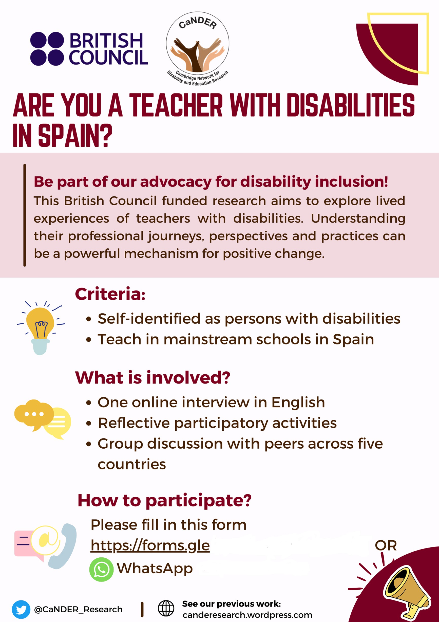

Appendix 2

Policies and official documents examined across the five countries

Ministry | Year | Policy/legislation
Rwanda (8)
Ministry of Education Rwanda  (MINEDUC) | 2018 | Special needs & inclusive education strategic plan 2018/19–2023/24
Ministry of Education Rwanda  (MINEDUC) | 2018 | Revised special needs and inclusive education policy
National Institute of Statistics Rwanda (NISR) | 2021 | Statistical Yearbook
National Institute of Statistics Rwanda (NISR) | 2021 | Labour Force Survey
Ministry of Justice Rwanda (MINIJUST) | 2007 | Law No. 01/2007 of 20/01/2007 Relating to Protection of Disabled Persons
Ministry of Local Government (MINALOC) | 2021 | National policy of persons with disabilities and four years strategic plan (2021–2024)
University of Rwanda | 2015 | Policy and guidelines on inclusive learning and teaching services
Ministry of Education Rwanda (MINEDUC) | 2007 | Teacher Development and Management Policy
Jordan (8)
Higher Council for the Rights of Persons with Disabilities & Ministry of Education | 2022 | Jordan declaration on inclusion and diversity in education
Ministry of Education & Higher Council for the Rights of Persons with Disabilities (HCD) | 2020 | The 10-Year Strategy for Inclusive Education
Ministry of Education | 2018 | Education Strategic Plan
The Hashemite Kingdom of Jordan | 2017 | Law No. (20) for the Year 2017  Law on the Rights of Persons with Disabilities Act
The Hashemite Kingdom of Jordan | 1952 | The Constitution of The Hashemite Kingdom of Jordan
Department of Statistics | 2020 | Statistical Yearbook 2020
The Hashemite Kingdom of Jordan | 2007 | The National Disability Strategy of The Hashemite Kingdom of Jordan
The Hashemite Kingdom of Jordan | 2015 | Education for prosperity: delivering results  A National Strategy for Human Resource Development 2016–2025

Ministry | Year | Policy/legislation
Brazil (2)
The National Congress | 2015 | The Brazilian Law on the Inclusion of Persons with Disabilities (Statute of Persons with Disabilities). LAW No. 13,146, of July 6, 2015
Ministry of Education | 2008 | ‘National Policy on Special Education from the perspective of Inclusive Education’  (política nacional de educação especial na perspectiva da educação inclusiva)
Spain (1)
Government of Spain | 2003 | The Royal Legislative Decree 1/2013, the General Law on Rights of Persons with Disabilities and their Social Inclusion (consolidated, General Law 13/1982 on Rights of Persons with Disabilities and their Social Integration, Law 51/2003 on Equal Opportunities, And the Law 49/2007 Equal Opportunities Act)
Instituto Nacional de Estadística (INE) – (National Statistics Institute) | 2022 | Employment of Persons with Disabilities (EPD) – Year 2022
Sri Lanka (7)
Minister of Social Services and Social Welfare | 1996 | Protection of the Rights of persons with Disabilities Act No. 28 of 1996
Ministry of Social Welfare – Sri Lanka | 2003 | National Disability Policy – for Sri Lanka
Ministry of Social Welfare – Sri Lanka | 2006 | A Disability Rights Bill – New Draft (DRB 2006)
Minister of Social Services and Social Welfare | 2006 | Disabled Persons’ Accessibility Regulations, No. 01 of 2006
Ministry of Social Welfare – Sri Lanka | 2016 | Redrafted Disability Rights Bill – 2016 (RDRB 2016)
Ministry of Public Administration – Sri Lanka | 1988 | Public Administration Circular No. 27/88
Department of Census and Statistics, Ministry of Finance and Planning – Sri Lanka | 2012 | Census of Population and Housing Report – 2012

This report aims to provide an insight into challenges, opportunities, policies, current practices and support networks that teachers with disabilities encounter within education systems. It provides perspectives on the lived experiences of English language and other subject teachers with disabilities in national education systems in Brazil, Jordan, Rwanda, Spain and Sri Lanka.
The report features primary data from interviews with 25 teachers who identified themselves as having visible or non-visible disabilities in these five countries, and presents findings from a policy and literature review.
The report aims to provide insight and recommendations for organisations involved in international development to design and deliver more inclusive education projects and programmes; to raise awareness of challenges and opportunities for teachers with disabilities; to inspire leaders, teachers and researchers; and to positively influence policymaking for more inclusive education systems.

